SUBCOURSE EDITION
IT0660 A

US ARMY INTELLIGENCE CENTER AND SCHOOL
ANALYZE MILITARY ACTIVITIES
AND INSTALLATIONS
ON AERIAL IMAGERY

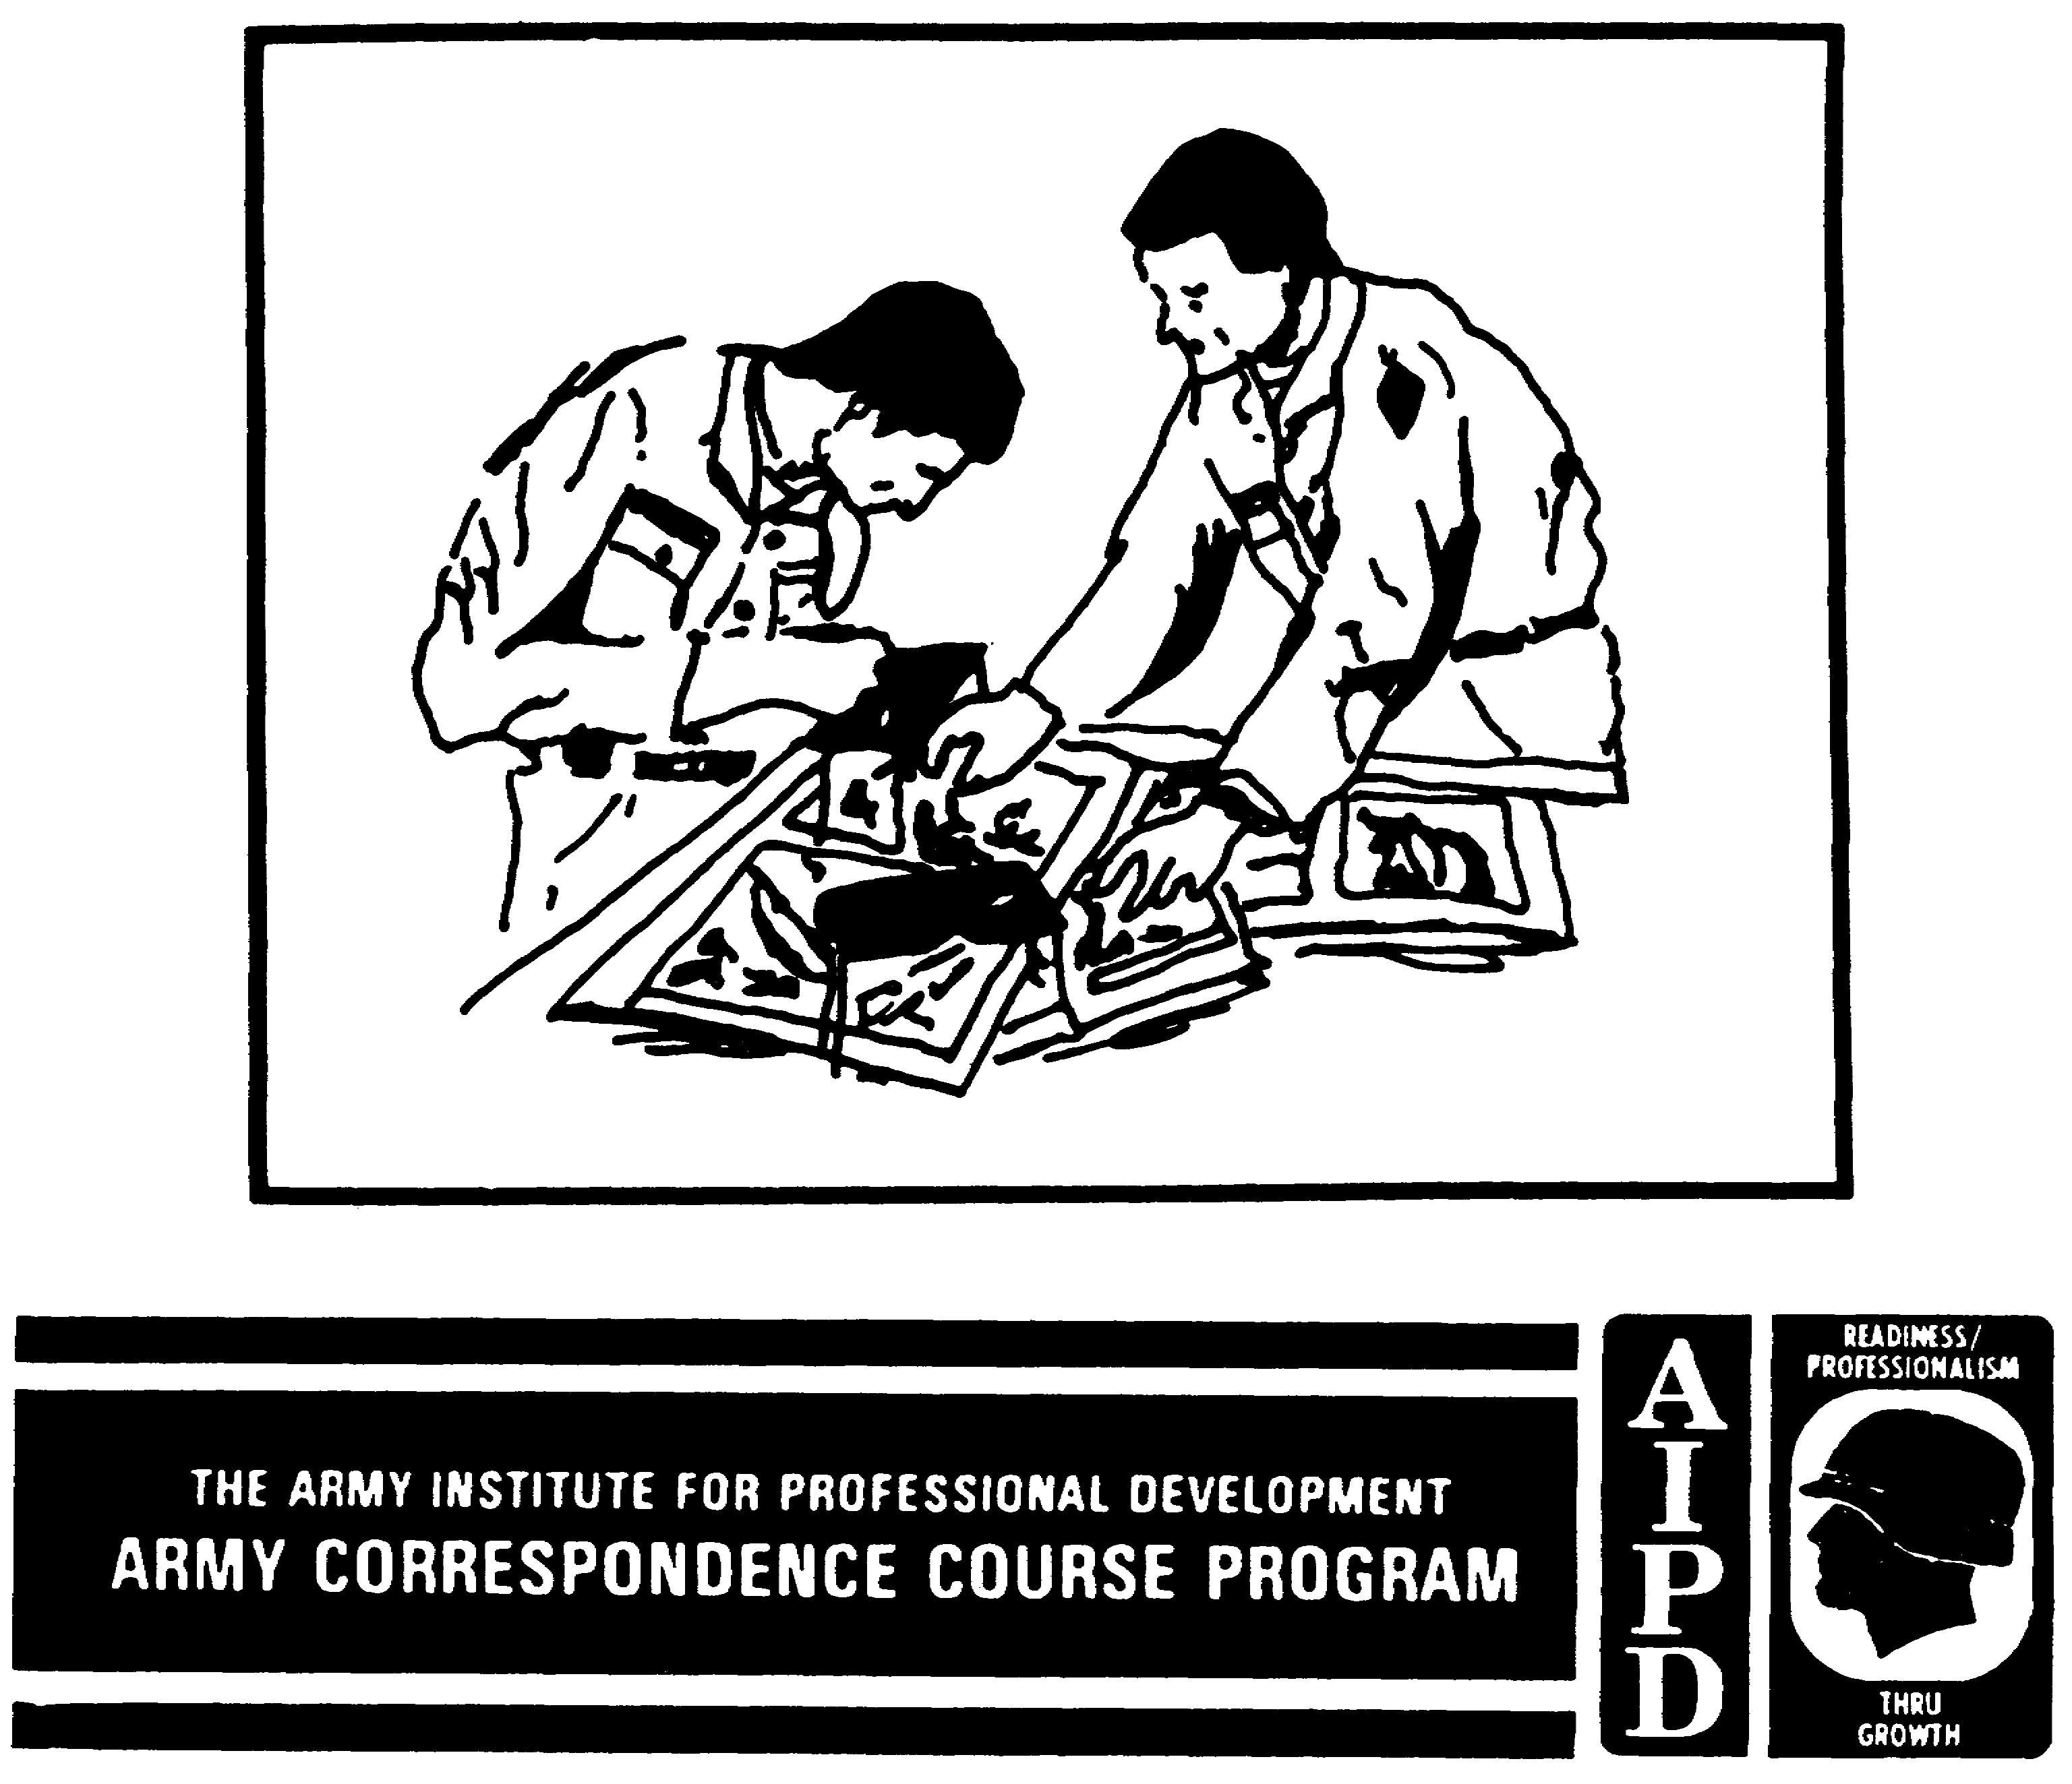

ANALYZE MILITARY ACTIVITIES AND INSTALLATIONS ON AERIAL IMAGERY

Subcourse Number IT0660

EDITION A

US Army Intelligence Center and School
Fort Huachuca, Arizona 85613-7000

3 Credit Hours

Edition Date: September 1990

SUBCOURSE OVERVIEW

This subcourse is designed to teach you basic procedures on how to analyze military activities and installations on aerial imagery. Contained within this subcourse are instructions on how to identify military and civilian installations and a combination thereof, and how to analyze military activities and installations.

There are no prerequisites to this subcourse.

This subcourse reflects the doctrine which was current at the time the subcourse was prepared.

TERMINAL LEARNING OBJECTIVES

TASKS: You will identify military and civilian installations and a combination thereof, and you will analyze military activities and installations.

CONDITIONS: You will have access to extracts from FM 23-1, FM 23-9, FM 23-67, FM 30-10, STP 34-96D1-SM, STP 34-96D24-SM-TG, TC 34-55, and TM 30-326.

STANDARDS: You will identify military and civilian installations and a combination thereof, and analyze military activities and installations in accordance with (IAW) FM 23-1, FM 23-9, FM 23-67, FM 30-10, STP 34-96D1-SM, STP 34-96D24-SM-TG, TC 34-55, and TM 30-326.

NOTE: Replace the following pages with glossy photo pages attached to the back of this subcourse for better viewing: 7, 8, 9, 18, 19, 20, 21, 28, 29, 31, 35, 49, 50, 55, 56, 57, 58, 59, and 61.

i IT0660

TABLE OF CONTENTS

Section Page

Subcourse Overview i

Lesson 1: Military and Civilian Installations 1

Part A: The 5 Ss 2

Part B: Using a Military Installation Key 6

Part C: Basic Military Activity and Installation
Features 11

Practice Exercise 14

Answer Key and Feedback 16

Lesson 2: Analyze Military Activities and Installations 17

Part A: Analyze Military Activities 18

Part B: Analyze Military Installations 22

Practice Exercise 48

Answer Key and Feedback 52

Appendix A: Acronyms 63

IT0660 ii

LESSON ONE

MILITARY AND CIVILIAN INSTALLATIONS

MOS Manual Tasks: 301-338-1809
301-338-3701

OVERVIEW

TASK DESCRIPTION:

In this lesson you will learn how to differentiate between military and civilian installations and a combination thereof.

LEARNING OBJECTIVE:

ACTIONS: Describe the information required to differentiate between military and civilian installations and a combination thereof.

CONDITIONS: You will be given access to extracts from FM 30-10, STP 34-96D1-SM, STP 34-96D24-SM-TG, TC 34-55, and TM 30-326.

STANDARDS: Identification of military and civilian installations and a combination thereof will be IAW FM 30-10, STP 34-96D1-SM, STP 34-96D24-SM-TG, TC 34-55, and TM 30-326.

REFERENCES: The material contained in this lesson was derived from the following publications:

FM 30-10.
STP 34-96D1-SM.
STP 34-96D24-SM-TG.
TC 34-55.
TM 30-326.

INTRODUCTION

One of the imagery analyst's (IA) important duties is to differentiate between military and civilian installations and a combination thereof. By knowing the general appearance of these installations and by applying this knowledge to the inspection of aerial imagery, the IA contributes valuable information.

1 IT0660

PART A: THE 5 Ss

There are five basic factors an IA uses to help in identifying an object, activity, or installation found on aerial photography. They are size, shape, shadow, shade, and surroundings (often called the "five Ss").

1. Size. The size of an object (Figure 1-1) can readily aid in its identification and also in the identification of surrounding objects.

a. If the scale of a vertical photo is known or can be-determined, it is a fairly simple process to take a measurement and determine the actual size of the object to be identified.

b. In the analysis of equipment, you should find accurate measurements are a must.

c. You can also use relative size. Look at Figure 1-1. If you know the object on the right is a house, by comparing the size of the center object to the known object (the house), you might determine it is a garage or large storage building. If you have made this deduction, you might decide the object on the left is a small storage shed or an outhouse.

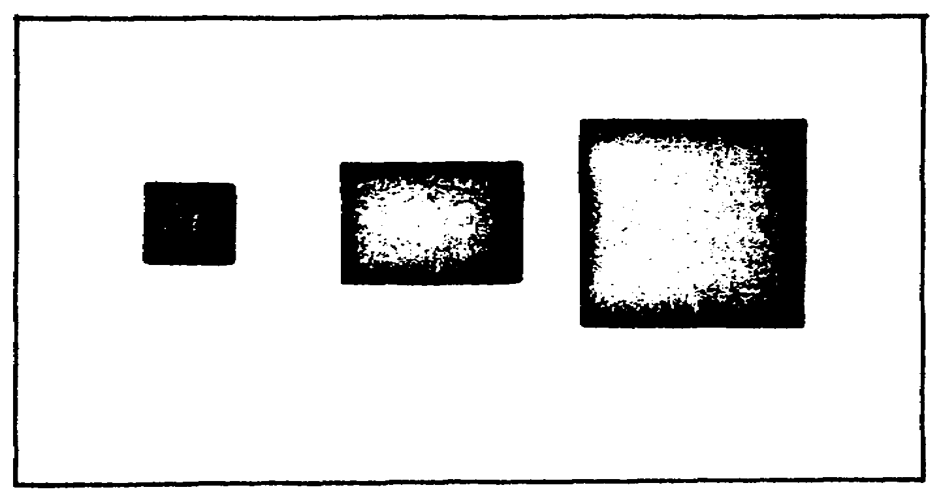

Figure 1-1. Size.

2. Shape. The shape of an object (Figure 1-2) is a definite aid in your identification process, because one of the first things you must do is determine whether the object is natural or manmade.

a. Natural terrain features are irregular in shape, but manmade objects have very regular geometric patterns with straight lines and regular curves. Using this knowledge, the IA can quickly scan a series of photographs and eliminate the irrelevant from the relevant, distinguish cultural features from those of military significance, and devote attention to the important area.

b. The importance of shape is further emphasized when you realize the enemy's camouflage efforts are primarily directed toward breaking up the shape of enemy installations and equipment.

IT0660 2



Figure 1-2. Shape.

3. Shadow. The pictorial effect and analysis of a vertical photo are greatly influenced by shadows.

a. The shape of an object is often more discernible from the shadow it casts than from its vertical (top) view (Figure 1-3). By studying the vertical image of an object together with its shadow, you can learn to associate the vertical appearance of that object with its angular side view as represented by the shadow. This enables you to form a mental image of the object as it would appear from the ground. An excellent example is a bridge, the shadow of which frequently reveals the construction of a bridge's supporting structure. Also, shadows allow the identification of electronic installations by revealing their characteristic antenna construction.

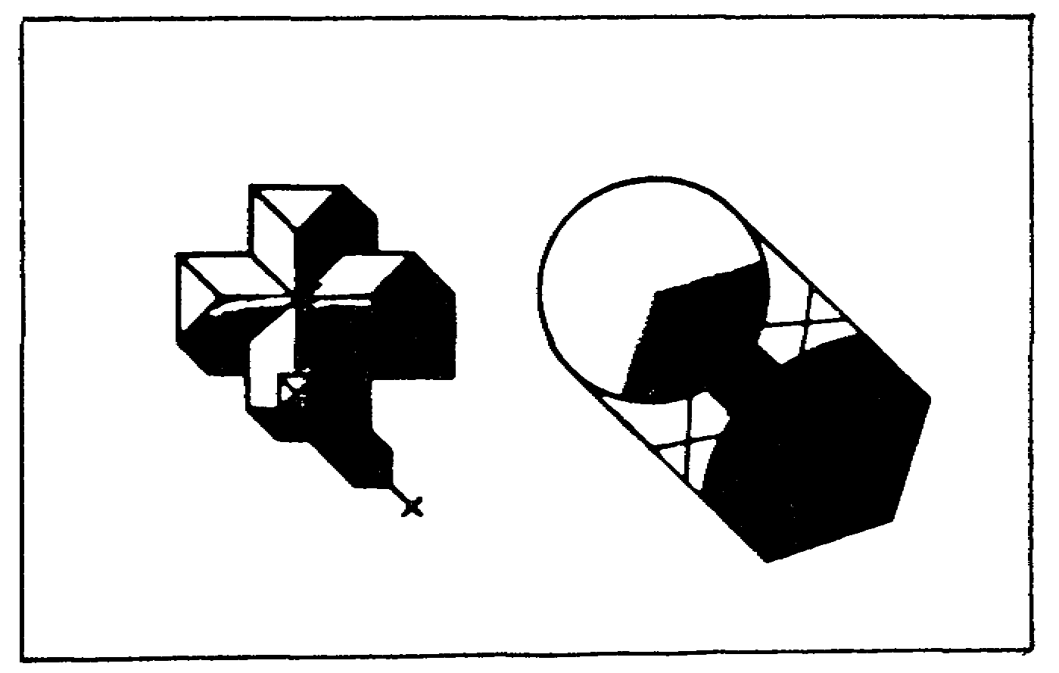

Figure 1-3. Shadow.

3 IT0660

b. Shadows also aid in the penetration of camouflage, which might otherwise successfully conceal a military installation or activity. Even fake shadows employed in camouflage can be easily detected on aerial photos, because camouflage shadows are usually painted on and appear in a true position to the sun at only one time of the day. Thus, shadows painted to appear true in the morning will be completely out of position in the afternoon.

c. Shadows further aid in the orientation of a photo with a map, as the shadows generally fall toward the north (between NW-NE) in the northern hemisphere, depending on the time of day.

d. Furthermore, shadows can hide objects as well. A tank parked in the shadow of a building or tree can be overlooked by the analyst who doesn't pay attention to such details as tank tracks leading up to, but not away from, the building or tree.

4. Shade. The distinguishable variations of gray in which an object appears on a black and white photo are known as its tone or shade. The shade of an object is almost entirely due to the amount of light reflected from it to the camera. Light reflection, in turn, depends on a number of contributing factors, such as the texture of the surface, position of the sun, and wind velocity.

a. Texture is the predominant factor in both light reflection and the shade it creates. Because of texture, objects will often appear much lighter on a photo than their color would seem to warrant. Some colors, however, reflect more light than others; for example, white reflects light and black absorbs it. A smooth surface is a good reflector and appears lighter when the camera is in a position to catch the reflected rays. On the other hand, if the reflected light does not reach the camera, a smooth surface will appear dark. An example is water, which sometimes appears light and sometimes dark, depending on the sun, position of the camera, and the velocity of the wind. Any change in texture of a portion of an object is evident on an aerial photo as a difference in shade.

b. The wind may disturb the reflecting surface of a body of water, or it may expose an entirely new surface to reflect light, as when the wind bends crops or vegetation. Therefore, the shade of an object may vary even on two consecutive photos of the same mission.

c. Thus when the earth, grass, or vegetation is crushed flat, say by a tank or truck, the reflected light will be altered from the norm. Depending on weather conditions, tracks made by one man walking across a grassy field can be detected up to 48 hours later on aerial photos taken from 30,000 feet.

d. The center object of the separated squares in Figure 1-4 reflects only part of the light shining on it; therefore, it is a medium shade. The rectangle on the right absorbs almost all light shining on it; therefore, it is a dark grey or black. The rectangle on the left reflects

IT0660 4

all the light; consequently, it is a light shade. The long object on the right could be a greenhouse. The glass roof reflects the light shining on it. The dark roof of the office absorbs the light.



Figure 1-4. Shade.

5. Surroundings. This factor is applied as an aid in the analysis in instances where an object under consideration is:

a. One of a number of similarly shaped objects, for example, shellholes or machine-gun positions.

b. Too small to be identified by size, shape, or shadow.

c. Unidentifiable after its size, shape, shadow, or shade have been considered. Then it is necessary to note the object in relation to other objects and features associated with or surrounding it. For example, antitank positions are usually found in close proximity to roadblocks; machine-gun positions usually line airstrips; radar units complement antiaircraft positions; manufacturing plants usually have electric transformer yards in the area.

d. Of the five factors of identification, surroundings are probably the most important to military identification. To make use of surroundings fully, you should be familiar with the enemy's weapons and equipment, organization and tactics, and the topographic and geographic aspects of the area of interest. The items in Figure 1-5 are groups of buildings. Both building groups are similar, but in different surroundings they are identified differently. Surrounded by cultivated fields, the group on the left becomes a farm with a house, barn, and silo. A railroad track added to the group of buildings on the right changes the analysis to a railroad station with a storage buildings and a water tank.

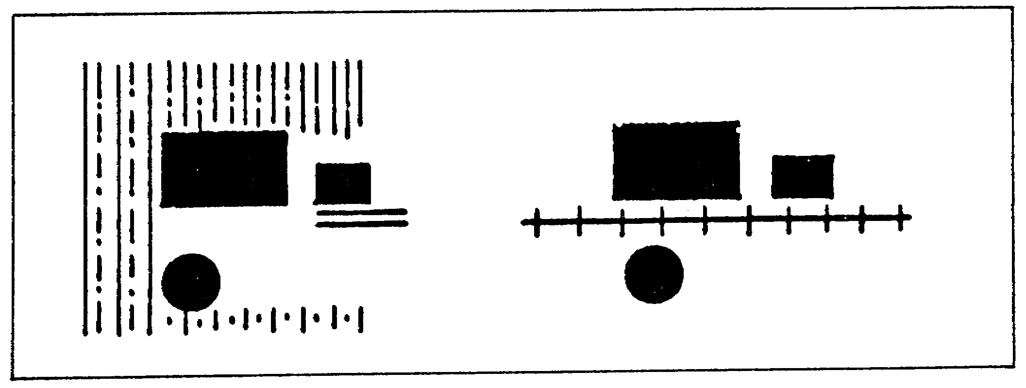

Figure 1-5. Surroundings.

5 IT0660

NOTE: Another factor of a more abstract nature is your own personal experience. You know what a school looks like because you are familiar with its structure, features, and surroundings. The same applies to the recognition of churches, parking lots, and industrial buildings. The soldiers who have been in combat areas can readily recognize defensive works such as trenches, bunkers, and machine-gun positions because of their makeup, concentration, and tactical layout on the ground. This knowledge aids you materially in developing the skill necessary to recognize and identify familiar objects on aerial photography.

PART B: USING A MILITARY INSTALLATION KEY

Military installations are items of military significance some of which could be confused with civilian activities. The following steps and key should assist you in your identification of military installations.

1. Step 1: Determine whether the image is natural or manmade (Figure 1-6).

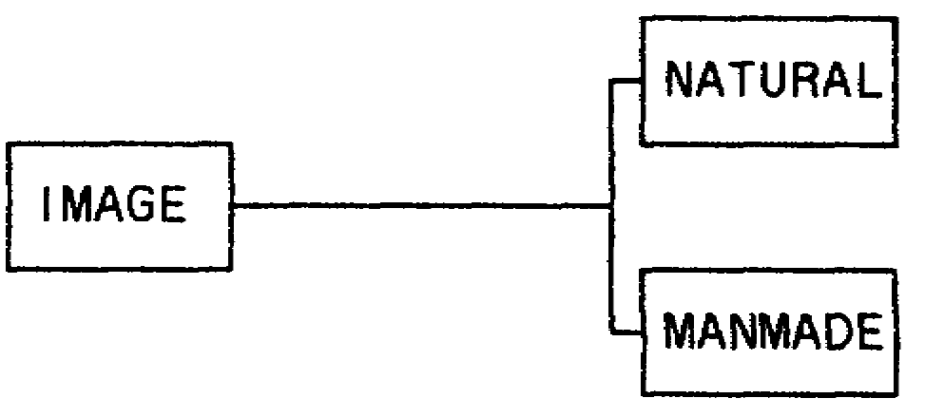

Figure 1-6. Image - Natural or Manmade.

a. Natural objects, such as trees, rocks, and shrubs, tend to have an irregular pattern.

b. Manmade objects, such as buildings, vehicles, fences, and bridges, tend to have even lines, distinctive shapes, and standard tones.

2. Step 2: Determine whether the image is a military or civilian installation, or a combination thereof (Figure 1-7).

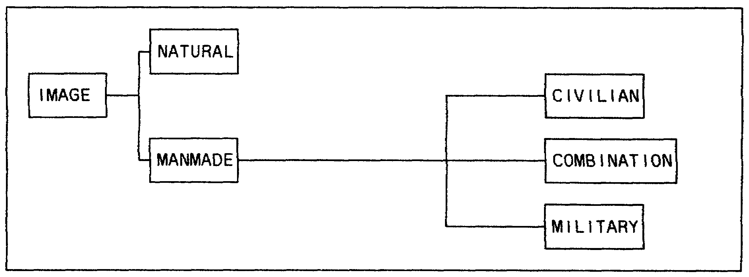

Figure 1-7. Civilian, Military, or Both.

IT0660 6

a. Civilian installations, such as cities, towns, or built-up areas, present no major problems to the IA. Under wartime conditions, however, with the resources and economy of a country geared toward the war effort, many activities require a second look, or closer examination, to determine their use. Essential war materiel and equipment and the facilities producing them are most often protected and secured by the military. What was once an auto-producing plant becomes a factory for armored or wheeled vehicles. Figure 1-8 shows typical civilian manmade features--Annotation A depicts an apartment or office building, B shows overpasses across a main street, and C indicates several office buildings.

NOTE: Knowledge of the situation and area is essential prior to analysis.

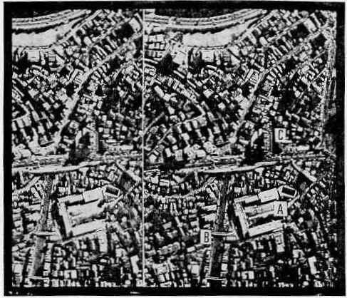

Figure 1-8. Typical Civilian Activity.

b. Military installations should be relatively easy to determine. Military posts, camps, forts, supply installations, and training areas, have certain definite characteristics associated with the military alone. You do not find, for example, the presence of motor pools, parade grounds, ammunition storage facilities, armored vehicles, artillery weapons, etc in a well-spaced or developed urban area. Furthermore, you would not associate a grouping of tents, barbed wire, and vehicles in a field or in the woods with civilian activities (Figure 1-9).

7 IT0660

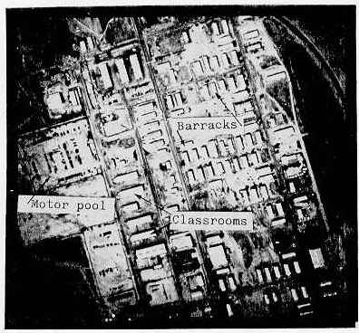

Figure 1-9. Typical Military Installation.

c. Combined Military and Civilian activities are airfields, port facilities, training areas, homeguard areas, reserve forces, and the like. Airports and port facilities fall in this category during peacetime as existing fields and ports are used for both military and civilian activities. Homeguard and reserve unit facilities can be identified by items of equipment, such as armored or wheeled vehicles, artillery, etc. Refer to Figure 1-10. Annotation A depicts a terminal normally used for civilian passenger service; civilian planes are parked or moving about the passenger ramps. Annotation B shows numerous aircraft parked in line which normally is not the case at civilian airfields. Further, Annotation C shows numerous fighter aircraft parked in line. At the southwestern portion of the runway (Annotation D) there are two special weapon storage areas with a fabrication plant nearby (Annotation E). Due to its dual use, this installation is a combination military and civilian airfield.

IT0660 8

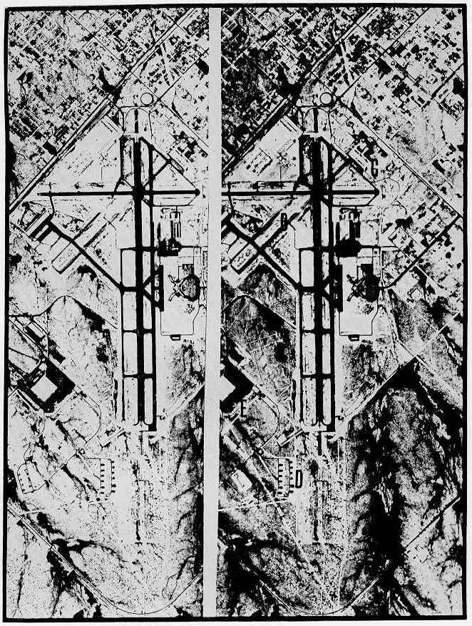

Figure 1-10. Combined Military and Civilian Installation.

9 IT0660

3. Step 3: Determine whether the installation is permanent or non-permanent
(Figure 1-11).

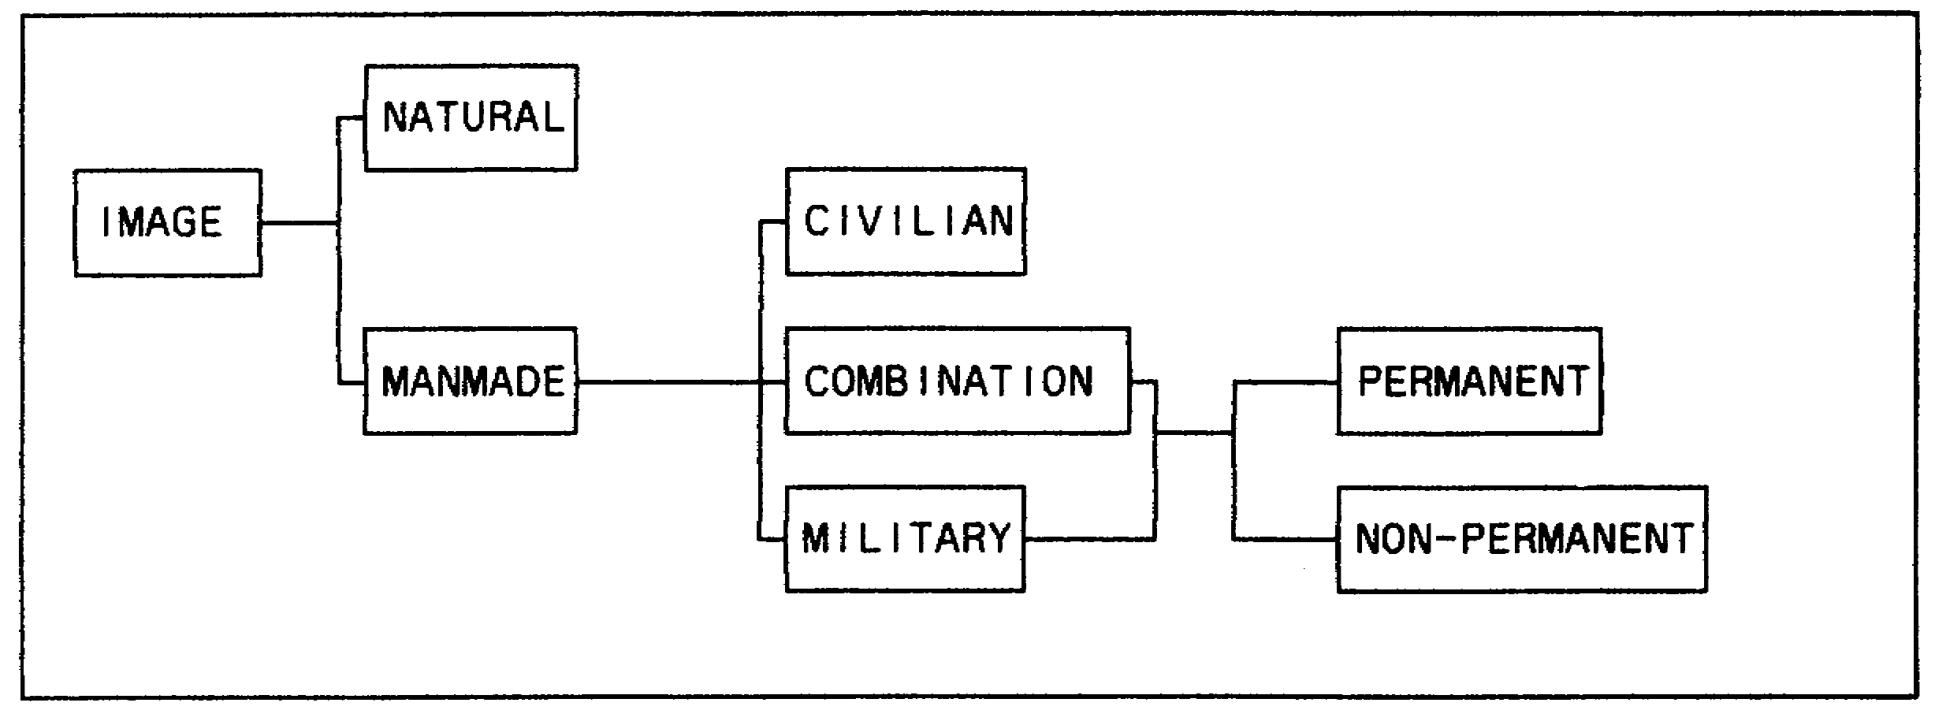

Figure 1-11. Permanent or Non-Permanent Installation.

a. Permanent. When military activity is of a permanent nature, analysis should be relatively simple. Permanent military installations and activities, such as motor pools, parade grounds, ammunition storage facilities, armored vehicles, and artillery weapons, are easily visible and always associated with military installations.

b. Non-permanent. You should consider military activity under two types of warfare: conventional and unconventional. This is done because of the variations in indications between these two types.

4. Step 4: Determine whether the installation is used in conventional or unconventional warfare (Figure 1-12).

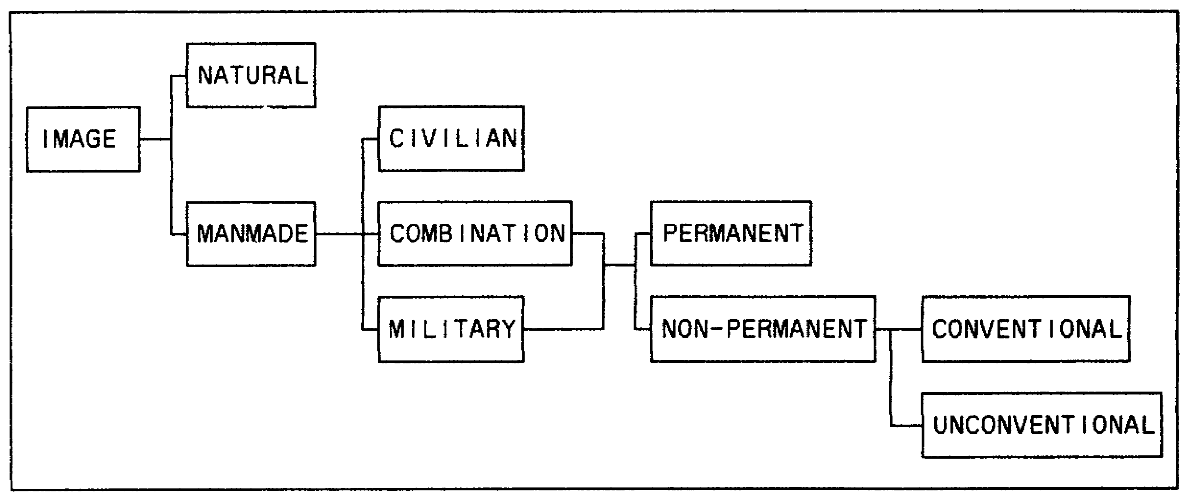

Figure 1-12. Conventional or Unconventional Warfare.

IT0660 10

a. In a conventional war, patterns develop which aid and assist the IA. In a conventional war, like World Wars I and II and the Korean conflict, the lines of contact were usually well-defined. One knew the Allies were on one side and the enemy was on the other side. Armies moved vast distances and still the line of contact was quite well-defined. Extensive field fortifications, such as trench systems, field artillery positions, air defense emplacements, bunkers, pillboxes, minefields, and supply facilities were employed. In other words, there was a definite forward edge of the battle area (FEBA).

b. Next, consider the aspects of unconventional or insurgent-type field activity, which does not have a FEBA. Because of the nature of this type of warfare, aerial recognition and analysis are extremely difficult. They do not follow the pattern of conventional warfare where there is a recognized line of contact, and the overall deployment of the enemy forces is generally known. Here the tactics are usually of an offensive nature, relying on the elements of mobility and surprise attacks, many of which are carried out during the hours of darkness. The enemy will vary its methods of attack to avoid setting up a pattern that can be counted on. The tactics usually employed are ambushes, raids, and harassing operations. Because of the secrecy and concealment so vital to this type of activity and because it is usually a short, intense, "hit and run" operation with a rapid withdrawal, it is almost impossible to detect indications for an attack from aerial imagery. Furthermore, there is a scattered mobile enemy with few fixed installations or positions. Vietnam was an excellent example.

PART C: BASIC MILITARY ACTIVITY AND INSTALLATION IDENTIFICATION FEATURES

1. When you scan a roll of imagery to locate military installations, you are concerned first with the characteristics that distinguish military from nonmilitary installations. The following eight basic identification features help you identify a military installation:

- Pattern.

- Uniformity.

- Enclosure.

- Vehicular activity.

- Military housekeeping.

- Exercise and recreational facilities.

- Military housing.

- Military equipment, defenses, and training facilities.

11 IT0660

NOTE: The two primary features of a military installation are uniformity and pattern. The other six features are not as obvious, but are usually present.

2. Military installations in all parts of the world have some or all of the basic identification features. However, factors such as military requirements, climate, terrain, availability of construction materials, and local customs and habits cause variations in appearance.

a. Pattern is a primary feature. Some obvious geometric pattern is usually evident at all military installations. Barracks and tents in all armies are usually laid out in a pattern. In forward areas, however, the tactical situation or terrain may make this impractical. At a training installation, barracks are usually aligned in rows with the headquarters in a central position. This situation also frequently exists at permanent supply depots.

b. Uniformity. The second primary characteristic of a military installation is uniformity. Most military installations have areas which exhibit a uniformity in size and shape of components. Uniformity is an outstanding feature of permanent supply depots and military posts. Because most buildings of a military installation are constructed of similar material, they usually have the same tone on imagery.

NOTE: Nonmilitary installations also exhibit pattern and uniformity, but usually not as clearly as a military installation. A city or town may be laid out in a regular pattern of blocks formed by intersecting streets, but the buildings in the blocks do not necessary continue the uniformity of the block pattern.

c. Enclosure. Another identification feature of military installations is an enclosing element. It is usually present, though sometimes difficult to locate. The installation may be enclosed with walls, fences, or natural features, such as shorelines. The entrances are limited and usually guarded by sentries. You may also find areas within the installation secured with fences. This could include areas of parked vehicles, grouped warehouses, POL storage, and weapons and ammunition storage.

d. Vehicular activity. The military need for mobility requires more vehicles than a similar nonmilitary activity. These vehicles are usually trucks and jeep-like carriers, rather than passenger cars. When the vehicles are not in use, they are ordinarily parked in dress-right-dress alignment. Careless track activity within and in the vicinity of the installations is normally present. Cannibalized equipment usually indicates vehicle repair and maintenance areas.

e. Military housekeeping. A neat appearance, reflecting good housekeeping, is usually apparent and more extensive on a military installation. Landscaping is often found around headquarters buildings

12 IT0660

and barracks. A network of paths, often bordered by white-washed stones, is frequently laid out between buildings.

f. Exercise and recreational facilities. Regardless of their size, military installations have some exercise and recreational facilities. A parade ground, also used for physical training is usually present. Lined athletic fields, when present, usually lack the spectator facilities found at a nonmilitary installation.

g. Military billeting/housing. Most military installations have billeting facilities for some or all of their assigned personnel. Military billeting whether temporary or permanent, is usually located in the area separate from the main buildings of the installation. On the other hand, private facilities (hotels, motels, and so on) usually have extensive parking areas for private vehicles.

h. Military equipment, defenses, and training facilities. This is the last distinguishing feature we will discuss, but we are not implying you should consider it last. Frequently the defenses and trenches around the buildings are the first indication that it is a military installation. Armored and tracked vehicles, personnel carriers, and weapons are designed for military use. Training facilities, such as firing ranges, obstacle course, parachute training towers, and maneuver areas, all indicate military activity. Equipment and defenses present small images on imagery, but in combination with other distinguishing features, they can help you identify a military installation.

NOTE: Some of the features of military installations are seen at nonmilitary installations. Some installations mistaken as military are industries, prisons and other institutions, large farms, and housing developments. The complete lack of military equipment and facilities is the most useful distinguishing feature for these installations (Figures 1-8 and 1-9).

13 IT0660

LESSON ONE

PRACTICE EXERCISE

The following items will test your grasp of the material covered in this lesson. There is only one correct answer to each item. When you have completed the exercise, check your answers with the answer key that follows. If you answer any item incorrectly, study again that part of the lesson which contains the portion involved.

1. Which is a primary feature of any military installation?

A. Enclosure.

B. Pattern.

C. Vehicular activity.

D. Housekeeping

2. What is your first step in using a military installation key?

A. Determine whether the image is natural or manmade.

B. Determine whether the image is a military or civilian installation.

C. Determine whether the image is a military installation or a military/civilian combination.

D. Determine whether the installation is permanent or non-permanent.

3. Which military installations should always have motor pools, parade grounds, ammunition storage facilities, and armored vehicles?

A. Unconventional.

B. non-permanent.

C. Permanent.

D. Combination.

IT0660 14

4. Which of the 5 Ss is the enemy's camouflage effort primarily directed toward?

A. Size.

B. Shadow.

C. Shade.

D. Shape.

E. Surrounding.

15 IT0660

LESSON ONE

PRACTICE EXERCISE

ANSWER KEY AND FEEDBACK

Item Correct Answer and Feedback

1. B. Pattern is a primary feature of any military installation (page 12, para 2a).

2. A. The first step in using a military installation key is to determine whether the image is natural or manmade (page 6, para 1).

3. C. Permanent military installations should always have motor pools, parade grounds, ammunition storage facilities, and armored vehicles
(page 10, para 3a).

4. D. The enemy's camouflage effort is primarily directed toward the shape of objects (page 2, para 2b).

IT0660 16

LESSON TWO

ANALYZE MILITARY ACTIVITIES AND INSTALLATIONS

MOS Manual Tasks: 301-338-1809
301-338-3701

OVERVIEW

TASK DESCRIPTION:

In this lesson you will learn how to analyze military activities and installations on aerial imagery.

LEARNING OBJECTIVE:

ACTIONS: Describe the information required to analyze military activities and installations on aerial imagery.

CONDITIONS: You will be given access to extracts from FM 23-1. FM 23-9, FM 23-67, FM 30-10, STP 34-96D1-SM, STP 34-96D24-SM-TG, TC 34-55, and TM 30-326.

STANDARDS: Analyzation of military activities and installations will be IAW FM 23-1, FM 23-9, FM 23-67, FM 30-10, STP 34-96D1-SM, STP 34-96D24-SM-TG, TC 34-55, and TM 30-326.

REFERENCES: The material contained in this lesson was derived from the following publications:

FM 23-1
FM 23-9
FM 23-67
FM 30-10.
STP 34-96D1-SM.
STP 34-96D24-SM-TG.
TC 34-55.
TM 30-326.

17 IT0660

PART A: ANALYZE MILITARY ACTIVITIES

Military activities are normally revealed by military equipment and personnel signatures.

1. Personnel. Personnel on foot can only be identified on large scale aerial photography. Considering the added factors of camouflage, cover, and concealment, the task of detecting personnel appears almost impossible except when in the open. You can, however, estimate troop strength within a given area based upon other military activity which is visible on the photographs. Figure 2-1 depicts personnel on foot (Annotation A) near a shower point (Annotation B); additionally, there are civilians at Annotation C as depicted by their attire and one individual being shorter than the others.

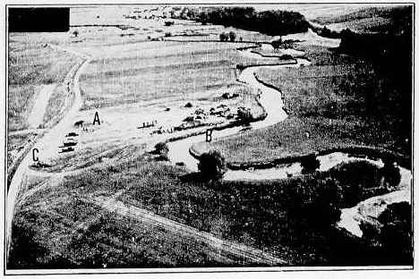

Figure 2-1. Personnel on Foot.

2. Vehicles. Track activity and wheel marks indicate military activity when there is nonconformity with the civilian or natural surroundings or a disregard for the economical use of the land. Civilian vehicles will normally travel on the existing road and avoid crossing fields.

a. Military vehicles, tracked or wheeled, will travel wherever the mission dictates. Frequently, important information on photos would be overlooked if it were not for the presence of track or wheel marks. A truck park forms a pattern of several loops in a wooded area near a major road. Figure 2-2 shows numerous trucks and their wheel marks.

IT0660 18

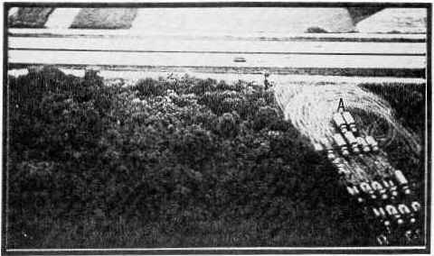

Figure 2-2. Trucks and Wheel Marks.

b. Wheeled vehicles will generally have a length-width ratio of 3:1. There are few exceptions to the rule, like the Gamma goat truck, but this ratio will generally apply.

c. Tracked vehicles or tanks will generally have a length-width ratio of 2:1. On a vertical aerial photo the length and width of a tank can be measured, the shape of the turret can be seen, and under the right conditions, the gun tube and muzzle brake, if present, can be detected.

3. Artillery. The term artillery is all-encompassing and includes the weapon, weapon site, ammunition storage, command posts, and fire direction or control center.

a. Locating artillery and missile launch sites on aerial photographs is an important, and at times, difficult task for an IA. It requires a full exploitation of the five basic factors of identification and the use of information from other intelligence sources and agencies, such as technical intelligence, order of battle, and interrogation personnel. Antiaircraft artillery (AAA) is easier to locate than field artillery, as AAA is usually found in the open (Figure 2-3).

19 IT0660

b. Once artillery is identified on aerial photography, you should classify it by examining the weapons site and associated installation.

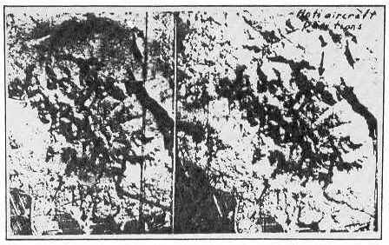

Figure 2-3. AAA Positions.

4. Radar. Radar has been playing an increasingly important role. It is used to detect aircraft and vessels, direct and control guided missiles. Radar antennas are shaped to suit their purpose, i.e., antenna masts for radio transmitters/receivers, radar antennas for missile guidance or missile intercept with an environmental cover (dome) over them (Figure 2-4). See subcourse IT 0676 for other radars.

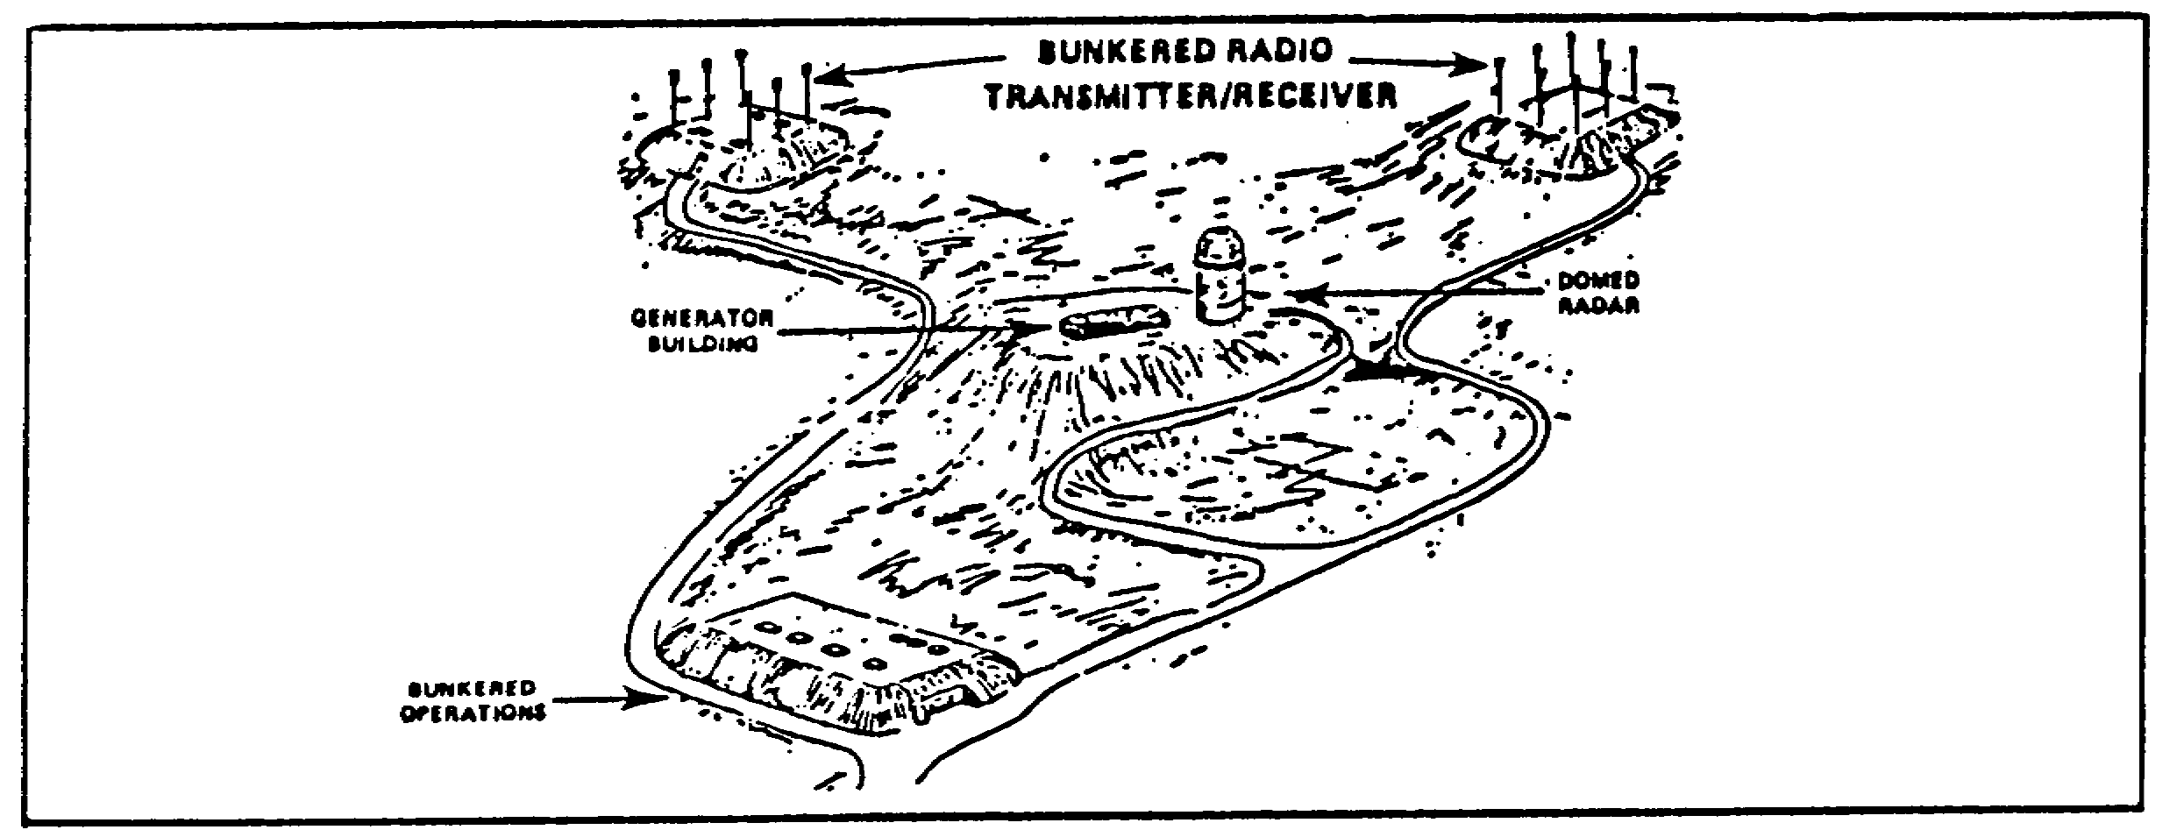

Figure 2-4. Radio Transmitter/Receiver Site and Domed Radar.

IT0660 20

5. Engineer activity. Engineer equipment other than river-crossing equipment resembles civilian engineer equipment; it can be identified on air photos by shape, shadow, and the surroundings in which it is located. River-crossing equipment is difficult to conceal and easy to identify by its characteristic size and shape (Figure 2-5). An armored-launched vehicle bridge (ALVB) is depicted at Annotation A.

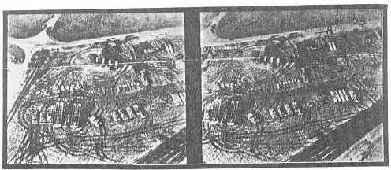

Figure 2-5. River-Crossing Equipment.

NOTE: For further study you may refer to the following ACCP subcourses:

Subcourse Number Equipment
IT0638 Engineer & Decontamination
IT0651 Artillery
IT0655 Tanks and Self-propelled Guns
IT0664 Armored Recovery Vehicles, Combat
Engineer Vehicles, and Armored Repair
Vehicles
IT0669 APC's and Tracked Primary Movers
IT0670 Trucks
IT0676 Electronics
IT0680 River-Crossing Equipment
IT0682 Rocket Launchers & Missiles
IT0688 Aircraft
IT0689 Helicopters

21 IT0660

PART B: ANALYZE MILITARY INSTALLATIONS

1. Personnel facilities of a fixed military installation include numerous activities, i.e., housing, headquarters building, guard houses, barracks, etc (Figure 2-6).

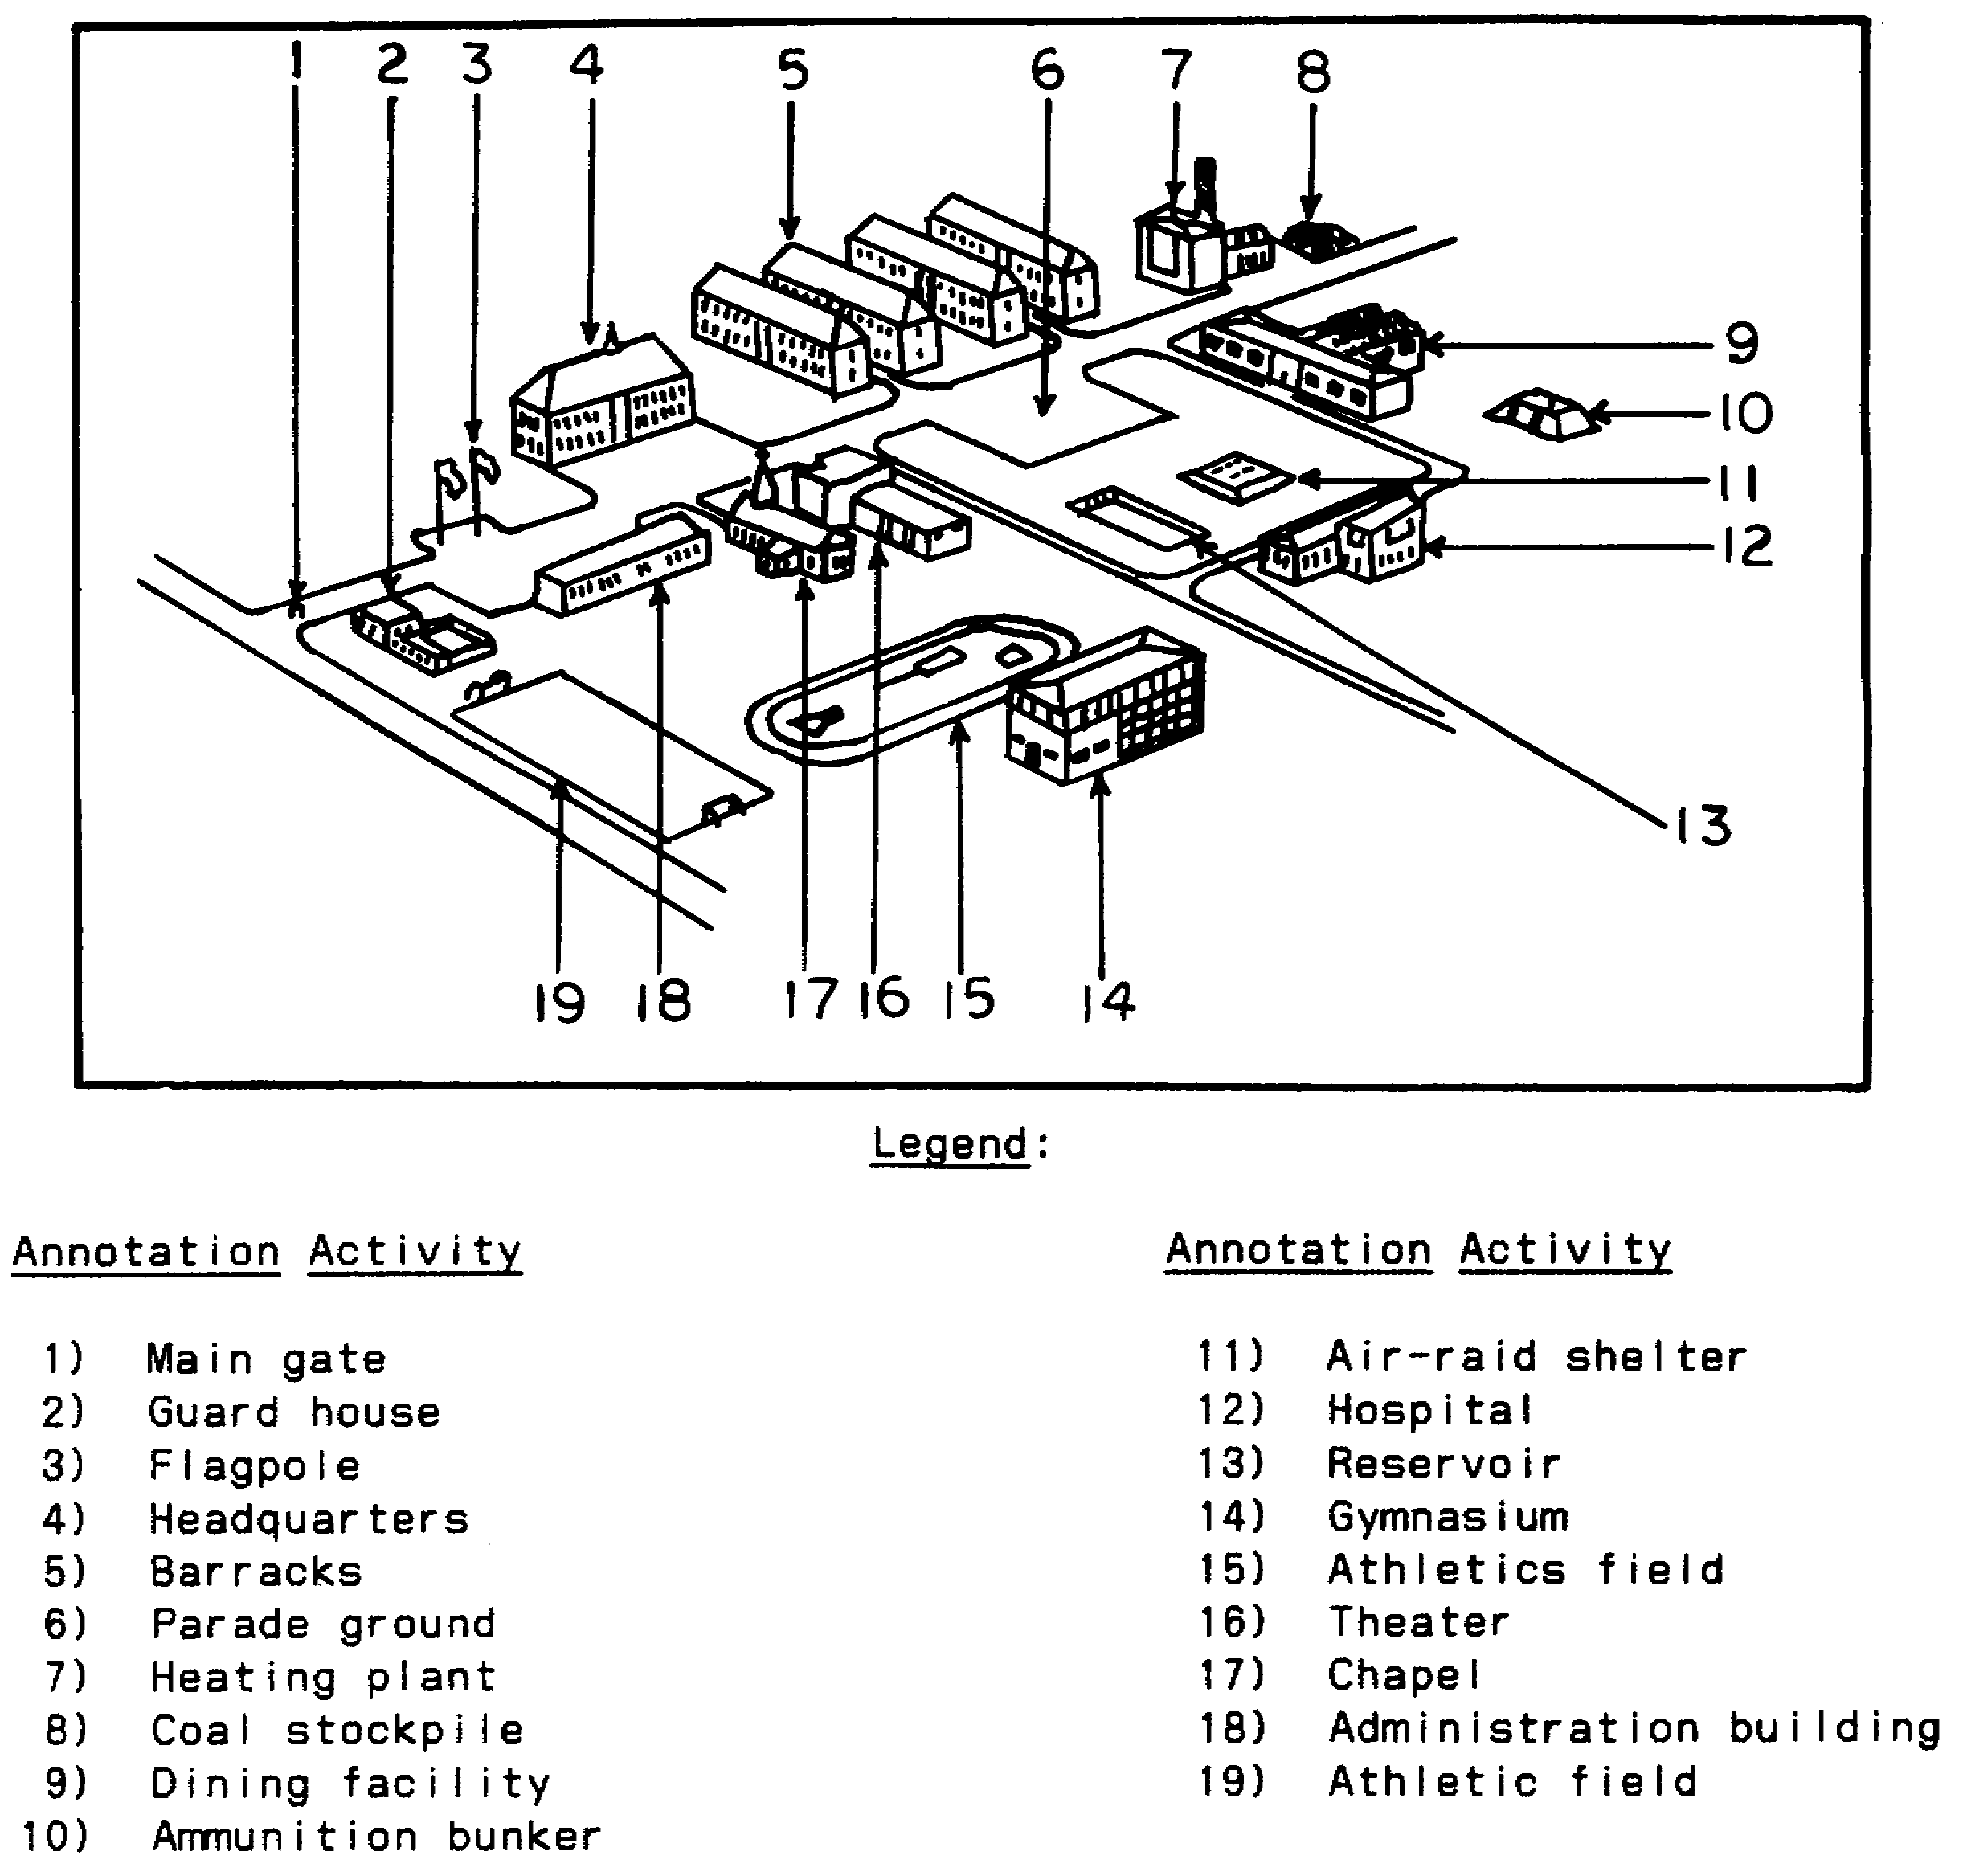

Figure 2-6. Fixed Military Installation.

a. Housing is the basic facility of military installations. Housing units include both barracks and family-type buildings. Buildings within these units or groups of units tend to be uniform in shape, size, and construction material. Well kept lawns and shrubs are common around housing units.

IT0660 22

(1) Housing units must also provide ample air and sunlight for health and morale. This is usually done by placing a large number of windows in narrow rectangular buildings. On oblique or ground imagery, these windows are a dominant recognition feature of personnel housing.

(2) There are usually roads throughout the housing area, but they are seldom laid out to provide specific access to individual buildings. A rail line or spur may pass near or through a housing area, but it does not terminate there.

b. Military housing facilities can usually be classified into one of three types: permanent, cantonment, or expedient. The basic factors used to classify housing are the construction material, structural features, location, arrangement, and density of buildings.

(1) Permanent housing is constructed of durable material--usually brick, stone, cinder block, concrete, stucco, or a combination. Most permanent barracks are two or three stories high with hipped and pitched roofs, though many have gabled roofs. The most common roofing materials are composition shingles, tile, and slate. A military installation with permanent-type housing is sometimes called a garrison.

(2) Cantonment or temporary housing is usually constructed of wood. The buildings are seldom more than one or two stories high. Pitched and hipped roofs, shingled or covered by strips of composition, are most common. Cantonment is used for mass troop billeting, particularly in training and maneuver areas. A military area with cantonment housing is frequently called a camp.

(3) Expedient housing. The third class of personnel housing includes huts, tents, and commandeered buildings grouped under the heading of expedient housing.

(a) Huts may be constructed from a variety of materials, including mud, grass, and bamboo. These construction materials blend in with their surroundings (a natural camouflage).

(b) Tents, versatile and easily transported, are practical for armies on the move. Because troops must become accustomed to their use, tents are often seen in training and maneuver areas.

(c) Commandeered housing can be any housing which satisfies a military requirement. Vehicular activity, military equipment, and defenses in the vicinity of the building indicate military use.

c. Headquarters. High-echelon headquarters seldom have military characteristics. They normally appear as large office buildings in the capital city of a country. You usually need ground information to identify the specific building serving as headquarters.

23 IT0660

(1) Post or base headquarters buildings, however, do have military characteristics. The headquarters building is usually located in the central or most prominent section of a military installation, frequently facing a parade ground. If the headquarters consists of more than one building, the main building usually has a flagpole on top or nearby. There are normally roads leading to the front of the headquarters building with parking facilities in the vicinity.

(2) The distinguishable feature of housekeeping is particularly evident. At a large installation the headquarters may occupy the largest building or a number of multistoried and multiwinged buildings. A small installation, however, may use barracks-type buildings and you usually need ground information to determine which barracks is the headquarters building (Figure 2-6).

2. Tactical facilities include tactical operation centers (TOC), command posts (CP), bivouacs, camps, etc.

a. TOC/CP (Figure 2-7). In a tactical situation a division or corps area is divided into a forward and a rear area. There are command and control elements in the forward area in addition to combat and combat support units. In the rear are the combat service support units and facilities providing the ammunition, POL, food, maintenance/repair, and manpower required at the front lines. The command and control elements in the forward area are organized into TOCs (CTOC for corps and DTOC for division) and CPs for brigade and lower echelon units. These TOCs are further organized in the main and the tactical TOCs/CPs. The service support functions in the rear area are controlled by the division/corps support command (DISCOM/COSCOM).

(1) Main TOC is generally located behind the line of contact/line of departure (LC/LD) out of enemy artillery range. It contains the majority of the staff and headquarters personnel involved in conducting operations (Figure 2-7).

(2) Tactical TOC is a small element located very near the forward line of own troops (FLOT). From the TOC, the commander and certain staff members direct combat operations. The TOC moves frequently during a 24-hour period to avoid detection. The CPs of units smaller than division are usually not split into main and tactical elements.

IT0660 24

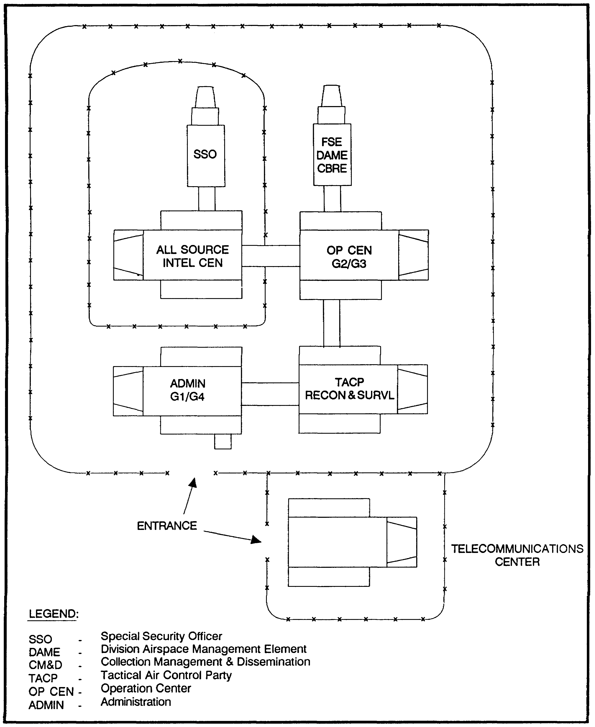

Figure 2-7. DTOC Layout.

25 IT0660

(3) Signatures and characteristics of TOCs/CPs. The size of the TOC/CP and the amount of activity in the area will vary with the echelon of command. CPs of lower echelons are hard to detect because they are small, easily camouflaged, and the center of comparatively little traffic. Division and larger unit TOCs are generally of such size, and the signs of their activities are so extensive, that it is difficult to completely camouflage them. Therefore, the detection of combined arms army and division TOCs is less troublesome to the IA. The technique most useful in identifying TOCs/CPs is comparative cover, which is defined as coverage of the same area or object taken at different times to show any changes in detail. Main TOCs for division and higher echelons, however, may often be located in castles, towns, or cities, with the elements of the TOC dispersed throughout the buildings. Pinpointing the location of these various scattered TOC/CP elements may be very difficult. The enemy will do all it can to camouflage and conceal the headquarters; comparative cover should reveal signs of activity and lines of communication and thus enable the IA to detect its location. In summary, comparative cover is the best means of detecting a TOC or CP.

(a) TOC/CP Identification Features. Converging lines of communication constitute the primary identification feature. Roads, footpaths, and wire lines converging in the area are indicative of a TOC/CP location. A TOC/CP may also be located near the terrain from which small liaison planes or helicopters can operate.

(b) Track activity. As already mentioned, tracks made by vehicles and personnel are difficult to control and are often a good indication of a concealed installation.

(c) Defenses. Small CPs are usually guarded by a few light weapons and tactical wire. The perimeter defenses of large TOCs may include light or medium air defense artillery gun emplacements, fighting positions, machine-gun emplacements, antitank mine belts, ditches and tactical wire.

(d) Vehicles dispersal areas. The vehicles serving the TOC/CP are dispersed within walking distances of the TOC/CP. They may be in woods, buildings, revetted emplacements, or camouflaged with brush or nets. The identification of vehicles in conjunction with other clues in the area may lead to the location of a TOC/CP. Personnel visiting higher headquarters have a tendency to avoid walking by driving as close to the TOC/CP as possible.

(e) Billets. The living area of personnel of a TOC/CP may show a pattern of paths worn between sleeping quarters, messing, and latrine facilities. The billeting area may include huts, tents, shelter trenches, or civilian dwellings and will usually be located within walking distance of the TOC/CP.

IT0660 26

b. Bivouacs are nonpermanent encampments of short durations in which troops are rested under improvised shelter and prepared for further movement. Bivouacs of small transitory units dispersed near the front line have little target value, but may be valuable sources of intelligence about unit movements. Larger bivouacs of a more permanent nature, particularly those in rear areas, are more valuable as targets. Larger bivouacs are an important indication of large-scale troop and equipment movement. There are several identification factors which lead to the discovery of bivouac areas:

(1) Equipment. It is very hard to hide large quantities of vehicles. Trucks, trailers, tanks, artillery, and engineer equipment are bulky and can be detected when studied on imagery under the stereoscope if they are not properly dispersed, or if the tree cover is too thin.

(2) Spoil. A large amount of digging is done at bivouac sites. The excess earth is usually piled up around each hole or ditch. This newly turned dirt will show up on imagery in different tones and shades than the surrounding soil.

(3) Tracks. When large quantities of vehicles are moving in the area, the track activity left by the vehicles will show up on imagery. It is almost impossible to hide track activity (Figure 2-8).

(4) Litter. Troops occupying an area usually leave small holes, broken shrubs, uprooted trees, crushed grass, paper, and other odds and ends, which cause an untidy appearance and are easily detected on imagery (Figure 2-8).

(5) Shelters vary from slit trenches or fighting positions covered with individual tents or tree branches to fairly elaborate shelters or bunkers, depending upon the length of the occupancy.

(6) Related features. Bivouacs contain garbage pits, latrines, field kitchens, and sometimes large recreation tents and headquarters shelters. The extent of these features will depend upon the size of the unit and the length of occupancy.

27 IT0660

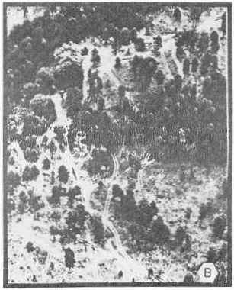

Figure 2-8. Typical Bivouac.

c. A camp is a group of tents, huts, or other shelter set up temporarily for troops and more permanent than a bivouac. Camps are found in rear areas; they are usually recognized by a compact and regular pattern. The camps of each country tend to conform to a pattern, and the experienced IA familiar with the enemy's pattern will have little difficulty in recognizing it. A study of our own camps will also aid the IA in identifying the enemy's activities. Organizational size, special facilities, and types and number of special equipment will indicate the type of camp (Figure 2-9).

IT0660 28

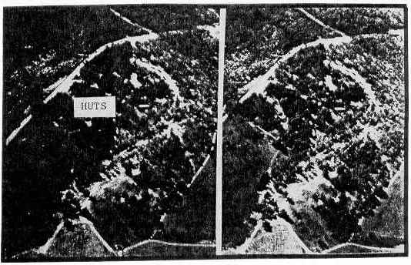

Figure 2-9. Typical Camp Area.

d. Prisoner of war (POW) camp (Figure 2-10). In a conventional conflict, POW camps are usually fenced or walled areas, with the appearance of self-contained miniature military camps. They are well isolated from surrounding facilities to discourage escape; furthermore, they are located well in the rear of the main line of resistance.

(1) Guard towers are an invariable indication of POW camps. These towers are spaced at regular intervals along the perimeter of the installation. Normally, every corner of the enclosure will mount a guard tower.

(2) The POWs living quarters present the same appearance as standard barracks and are likely to be lined up in much the same manner. A distinguishing feature is the considerable area between the barracks and the fences or walls. Open areas within the compound are used for lineups and exercise areas. Auxiliary buildings found just outside the compound may include hospitals, supply buildings, and so on. They can be identified only by their proximity to the compound, because they are probably converted barracks and present the same appearance on aerial photos as do the buildings within the compound.

29 IT0660

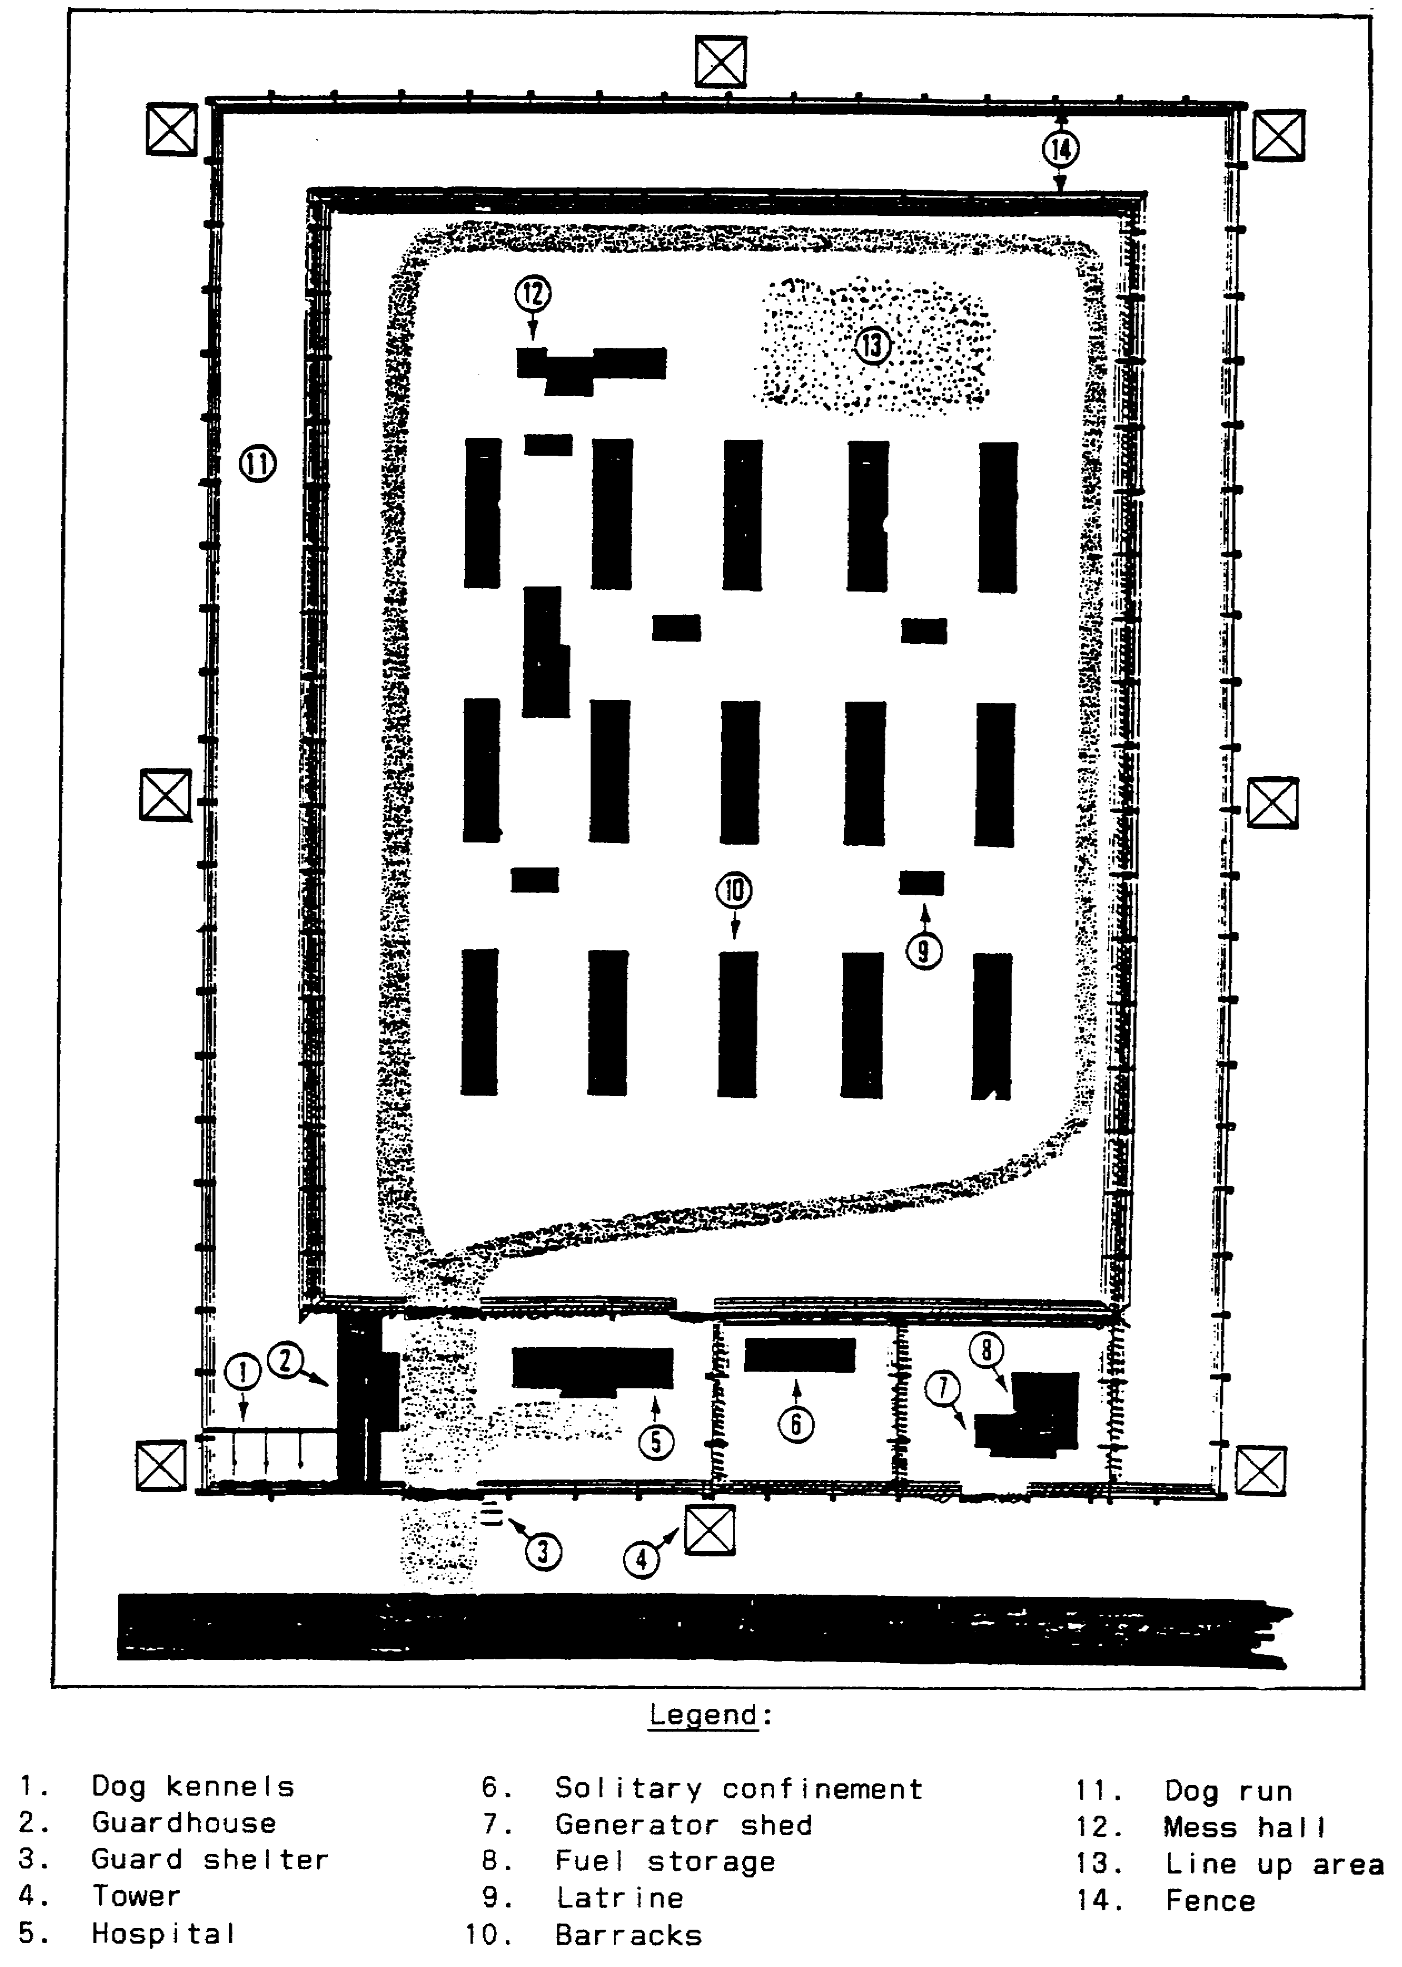

Figure 2-10. Typical POW Camp Layout.

IT0660 30

e. Field hospitals are campsites except they are purposely set up in the open (Figure 2-11). Note the Red Cross marking at some of the tent tops.

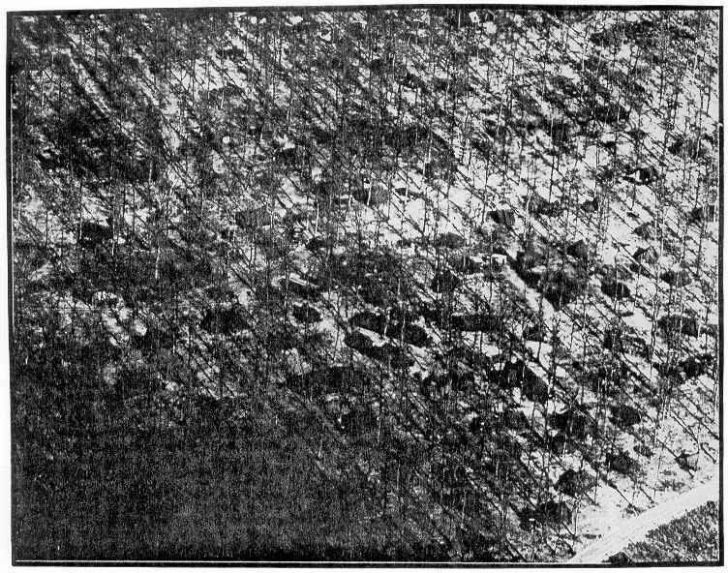

Figure 2-11. Field Hospital in the Open.

31 IT0660

3. Logistical Facilities include supplies, ammunition, petroleum, oil, and lubricants (POL), and general supplies. Prior to analyzing logistical facilities you should obtain an understanding of the supply delivery methods.

a. Supply channels. The supply systems start at mines, farms, and forests which are the sources of most raw materials. The raw materials are transported to processing and assembly plants, and the end products are placed in warehouses prior to shipment. If the enemy is not fighting in its own country, the next step is transportation to a location in or near the combat area. Up to this point, the supply operation is usually beyond the range of the tactical ground commander and is targeted for strikes by strategic forces.

(1) Upon arrival at a main supply port or railhead, supplies may be within the range of tactical weapons, and may be well into the tactical IA's field of search. From this point in the system, supplies will be prepared for distribution to lower echelons. Assuming the operating force is a Soviet Front, the first distribution will be to the combined arms army. From army, they will go to divisions and then, in turn, to regiments or brigades, battalions, and companies, finally reaching individual troops. There will be some variation from these channels due to the location or disposition of troops, but variations will be the exception rather than rule. For targeting purposes, supplies in the hands of the user are no longer considered supplies.

(2) By describing the supply system, the largest supply concentrations become smaller and smaller as they approach the using troops. Therefore, the best places to look for supplies are in the rear areas, and the search in areas closer to the front line are less successful. It is to be expected most targetable supply concentrations will usually be found between the main supply port and division supply dump. Beyond the latter point, concentrations may be too small for profitable targeting.

b. Characteristics. The fighting effectiveness of an enemy is heavily dependent upon supply of food, water, ammunition, clothing, POL, and replacement equipment such as trucks, tanks, river-crossing material, and artillery. Several of these items have attendant features which aid in their separate identification. Others are packaged or crated in such a manner that positive identification cannot be made from aerial photography alone and may be reported as supplies without naming the type. Regardless of the materials stored in them, supply installations have certain common characteristics which are almost always present.

IT0660 32

(1) The requirement for speedy handling leads to signatures. For example, the installation will practically always be near a good road. This is essential for the speed and efficiency of motor transport facilities required for modern armies; moreover, cross-country travel with heavy loads can cause significant delays.

(2) For the convenience of vehicles there will often be roads within the installation leading to each of the dispersed stacks or bunkers. In many instances, a road loop is formed so vehicles can enter the area in convoy. This is to avoid the congestion and difficulty caused by some vehicle backing up for loading while others are entering the facility (Figure 2-12).

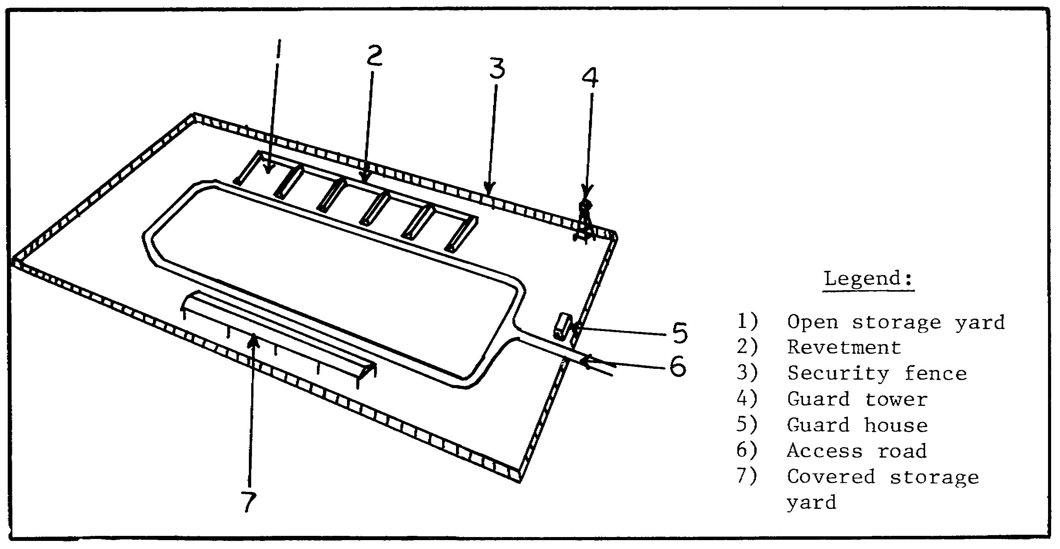

Figure 2-12. Typical Supply Storage Facility Layout.

(3) Two basic requirements in the storage of materials are in conflict: convenience of access and protection devices, such as revetments and dispersion, hamper the handling of supplies. Such methods are used when the supplies are explosives or flammables, or when there is a real threat of air attack.

(4) When a supply facility is located far enough away to be relatively safe from the enemy, emphasis is placed on easy handling and efficient storing of material; concentration, rather than dispersion, is the key note. Under these conditions, buildings are grouped relatively close together and arranged as a unit.

33 IT 0660
c. The following recognition features are common to all supply facilities:

(1) Buildings are often long and rarely more than two stories high.

(2) The internal road network is well developed; railroad spurs may be present.

(3) Parade grounds and recreational areas are not present.

(4) Landscaping and gardening are not apparent.

(5) Open storage piles are visible; often large, and resemble small buildings.

(6) Track activity is visible; numerous vehicles may be present.

(7) Guard towers and controlled gates usually enclose and further protect the area.

d. Ammunition facilities. The hazards involved in handling and storing explosives require a storage pattern easily identified on imagery. The most important characteristic of ammunition storage is dispersal. Other types of supplies may be spread out, but none so carefully as explosives. This is done to reduce the possibility of sympathetic explosions, and explosions caused by shock waves from another explosion. Ammunition storage facilities are usually located away from population centers for safety. At times, they are located underground in caves.

(1) The second most frequently observed characteristic is an enclosure, usually more elaborate than at other supply facilities. In many instances, guard towers are visible at regular intervals and roadblocks are present at the entrances.

(2) Although fuel depots are occasionally revetted, the presence of revetments in a supply facility is often a positive indication of ammunition storage. Revetments, too, serve as protection against sympathetic explosions and enemy attack.

(3) The transportation network in an ammunition depot or dump differs significantly from those for other types of supply. Here the network is designed to give maximum separation to storage points. Even when two or more spurs run parallel, there is a wide separation between them. Road nets may consist of simple or complex loops and often present a neat appearance.

(4) When ammunition is stored underground, the presence of such a facility is often disclosed by tunnel entrance and track activity in the vicinity of the entrances. Driveways leading to the entrances are generally visible (Figure 2-13).

IT0660 34

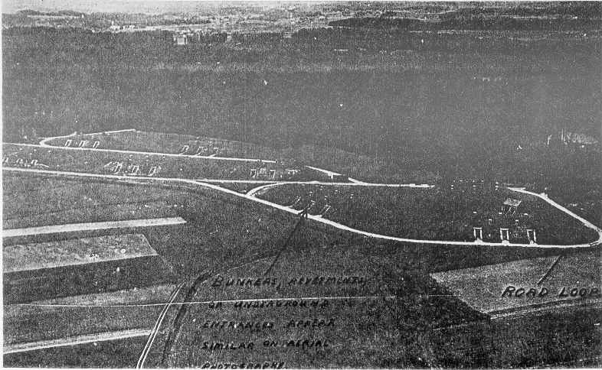

Figure 2-13. Ammunition Storage Depot.

NOTE: An ordnance plant normally has a large ammunition storage facility in the immediate area.

e. Bomb storage is similar to ammunition storage. Bombs are stored in remote areas near an ordnance plant and airfields. They are surrounded by blast walls to eliminate sympathetic detonation. An access road leads to each storage bunker. Furthermore, a road loop is formed so vehicles can enter the area in convoy (Figure 2-14).

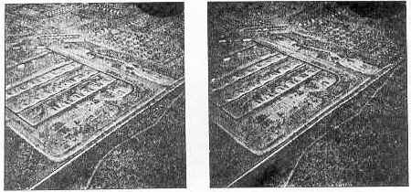

Figure 2-14. Bomb Storage Site.

35 IT0660

f. POL. The large fuel supply facilities normally engage in three activities: dispensing, storing, and transshipping. While all these activities are often found together in a single depot or dump, each has its own group of distinguishing features.

(1) Dispensing facilities vary from small, temporary POL points to elaborate activities in rear areas. The small temporary POL points may consist of a small number of fuel drums only. Such sites are usually level and cleared with enough space for an unrestricted flow of traffic. A POL supply point can also be identified by heavy track activity and the presence of vehicles alongside a road, fuel containers, and oil stains. The more elaborate facilities have the same general characteristics, but include buildings for loading racks, and storage tanks.

(2) Storage. The most prominent feature of a fuel storage activity is the storage tanks (Figure 2-15). If the tanks are buried, circular earth scars are usually visible, and the earthen covering may appear as a mound. Storage tanks may be covered by camouflage nets. Often such camouflage is a failure, since the large tanks are difficult to hide. Also, firewalls, pipelines, and pumping stations indicate the presence of a fuel facility.

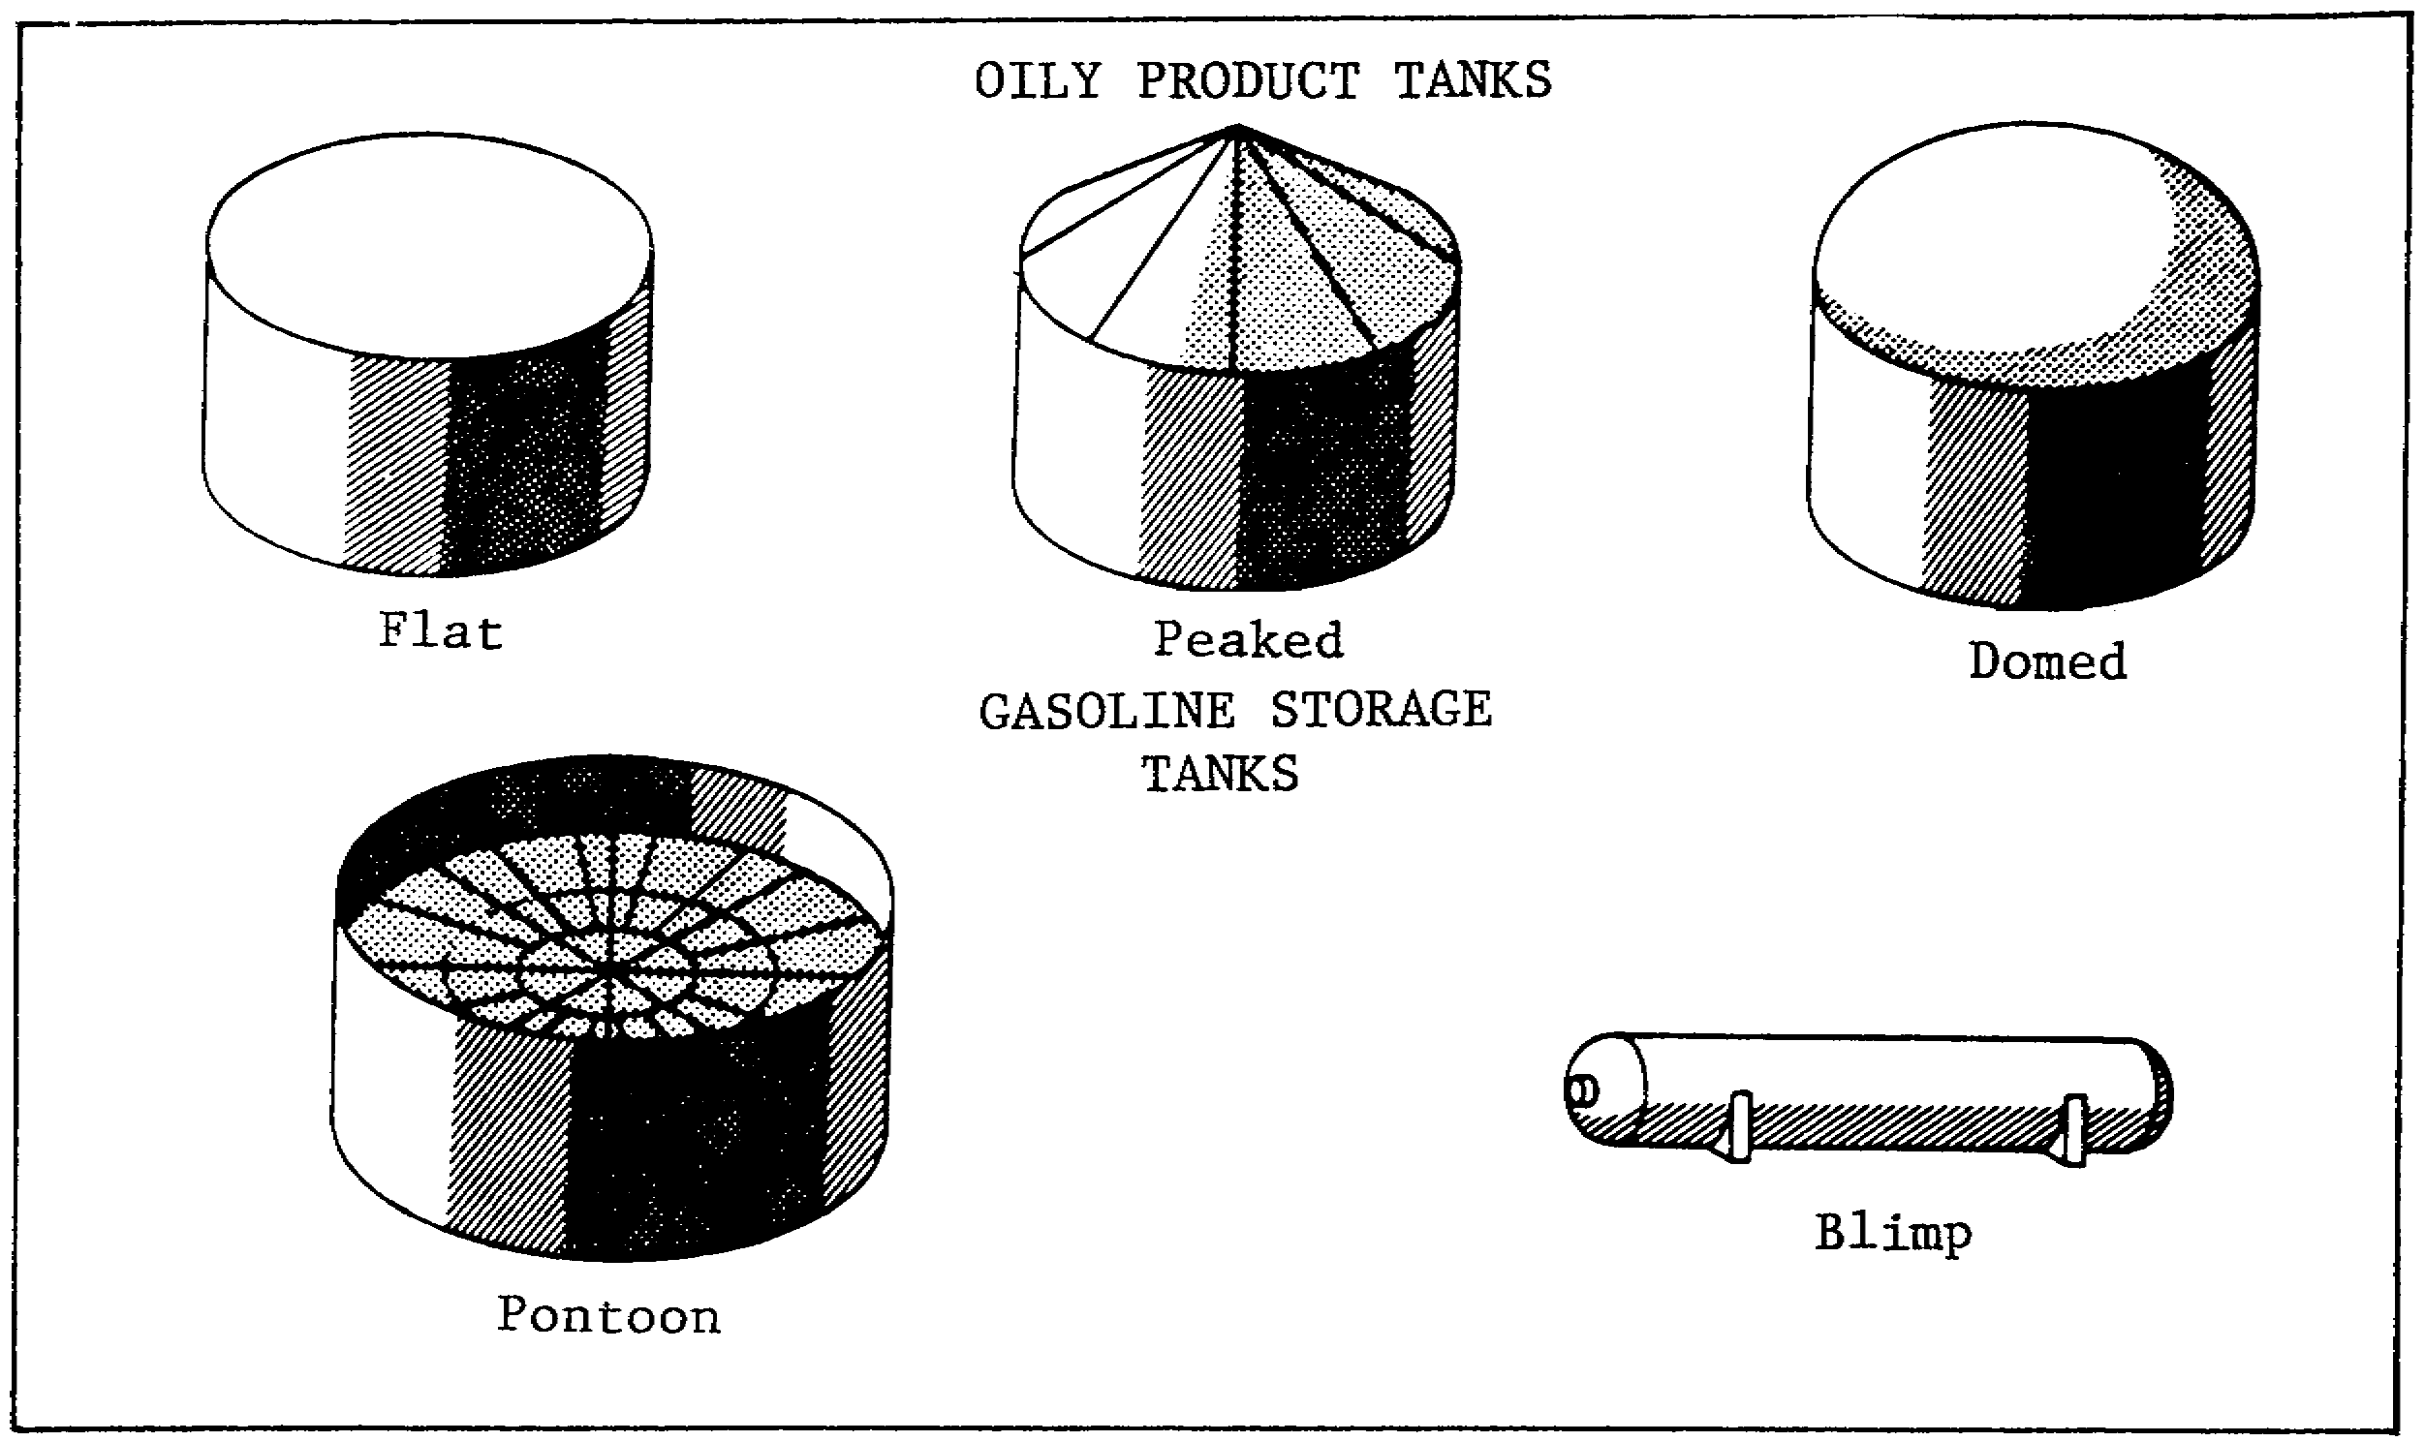

Figure 2-15. POL Storage Tanks.

IT0660 36

(3) Transshipment. The specific pattern of a transshipment activity depends on the site and conditions involved.

(a) A water site (Figure 2-16) has specialized piers or evidence of an underwater pipeline to offshore dolphins. Storage tanks are usually visible close to the shore area.

(b) A rail site (Figure 2-17) has specialized piers or evidence of an underwater pipeline to offshore dolphins. Storage tanks are usually visible close to the shore area. A rail site has many rail spurs, loading racks, pumping stations, and storage tanks. Tank cars are often present.

(c) Motorized transshipment sites (Figure 2-18) are often associated with rail sites. A well-developed road net, hardstands, tank trucks, loading racks, storage tanks, and pipelines may also be present.

NOTE: POL products, particularly gasoline are usually inflammable and therefore subject to precautionary measures in storage as ammunition is.

NOTE: The marked difference between POL and ammunition is in the shipping containers. The IA should be aware POL products used in a field environment are usually in liquid form and, as a result, are transported and stored in bulk on POL trucks, in 55-gallon drums, or in 5-gallon cans.

37 IT0660

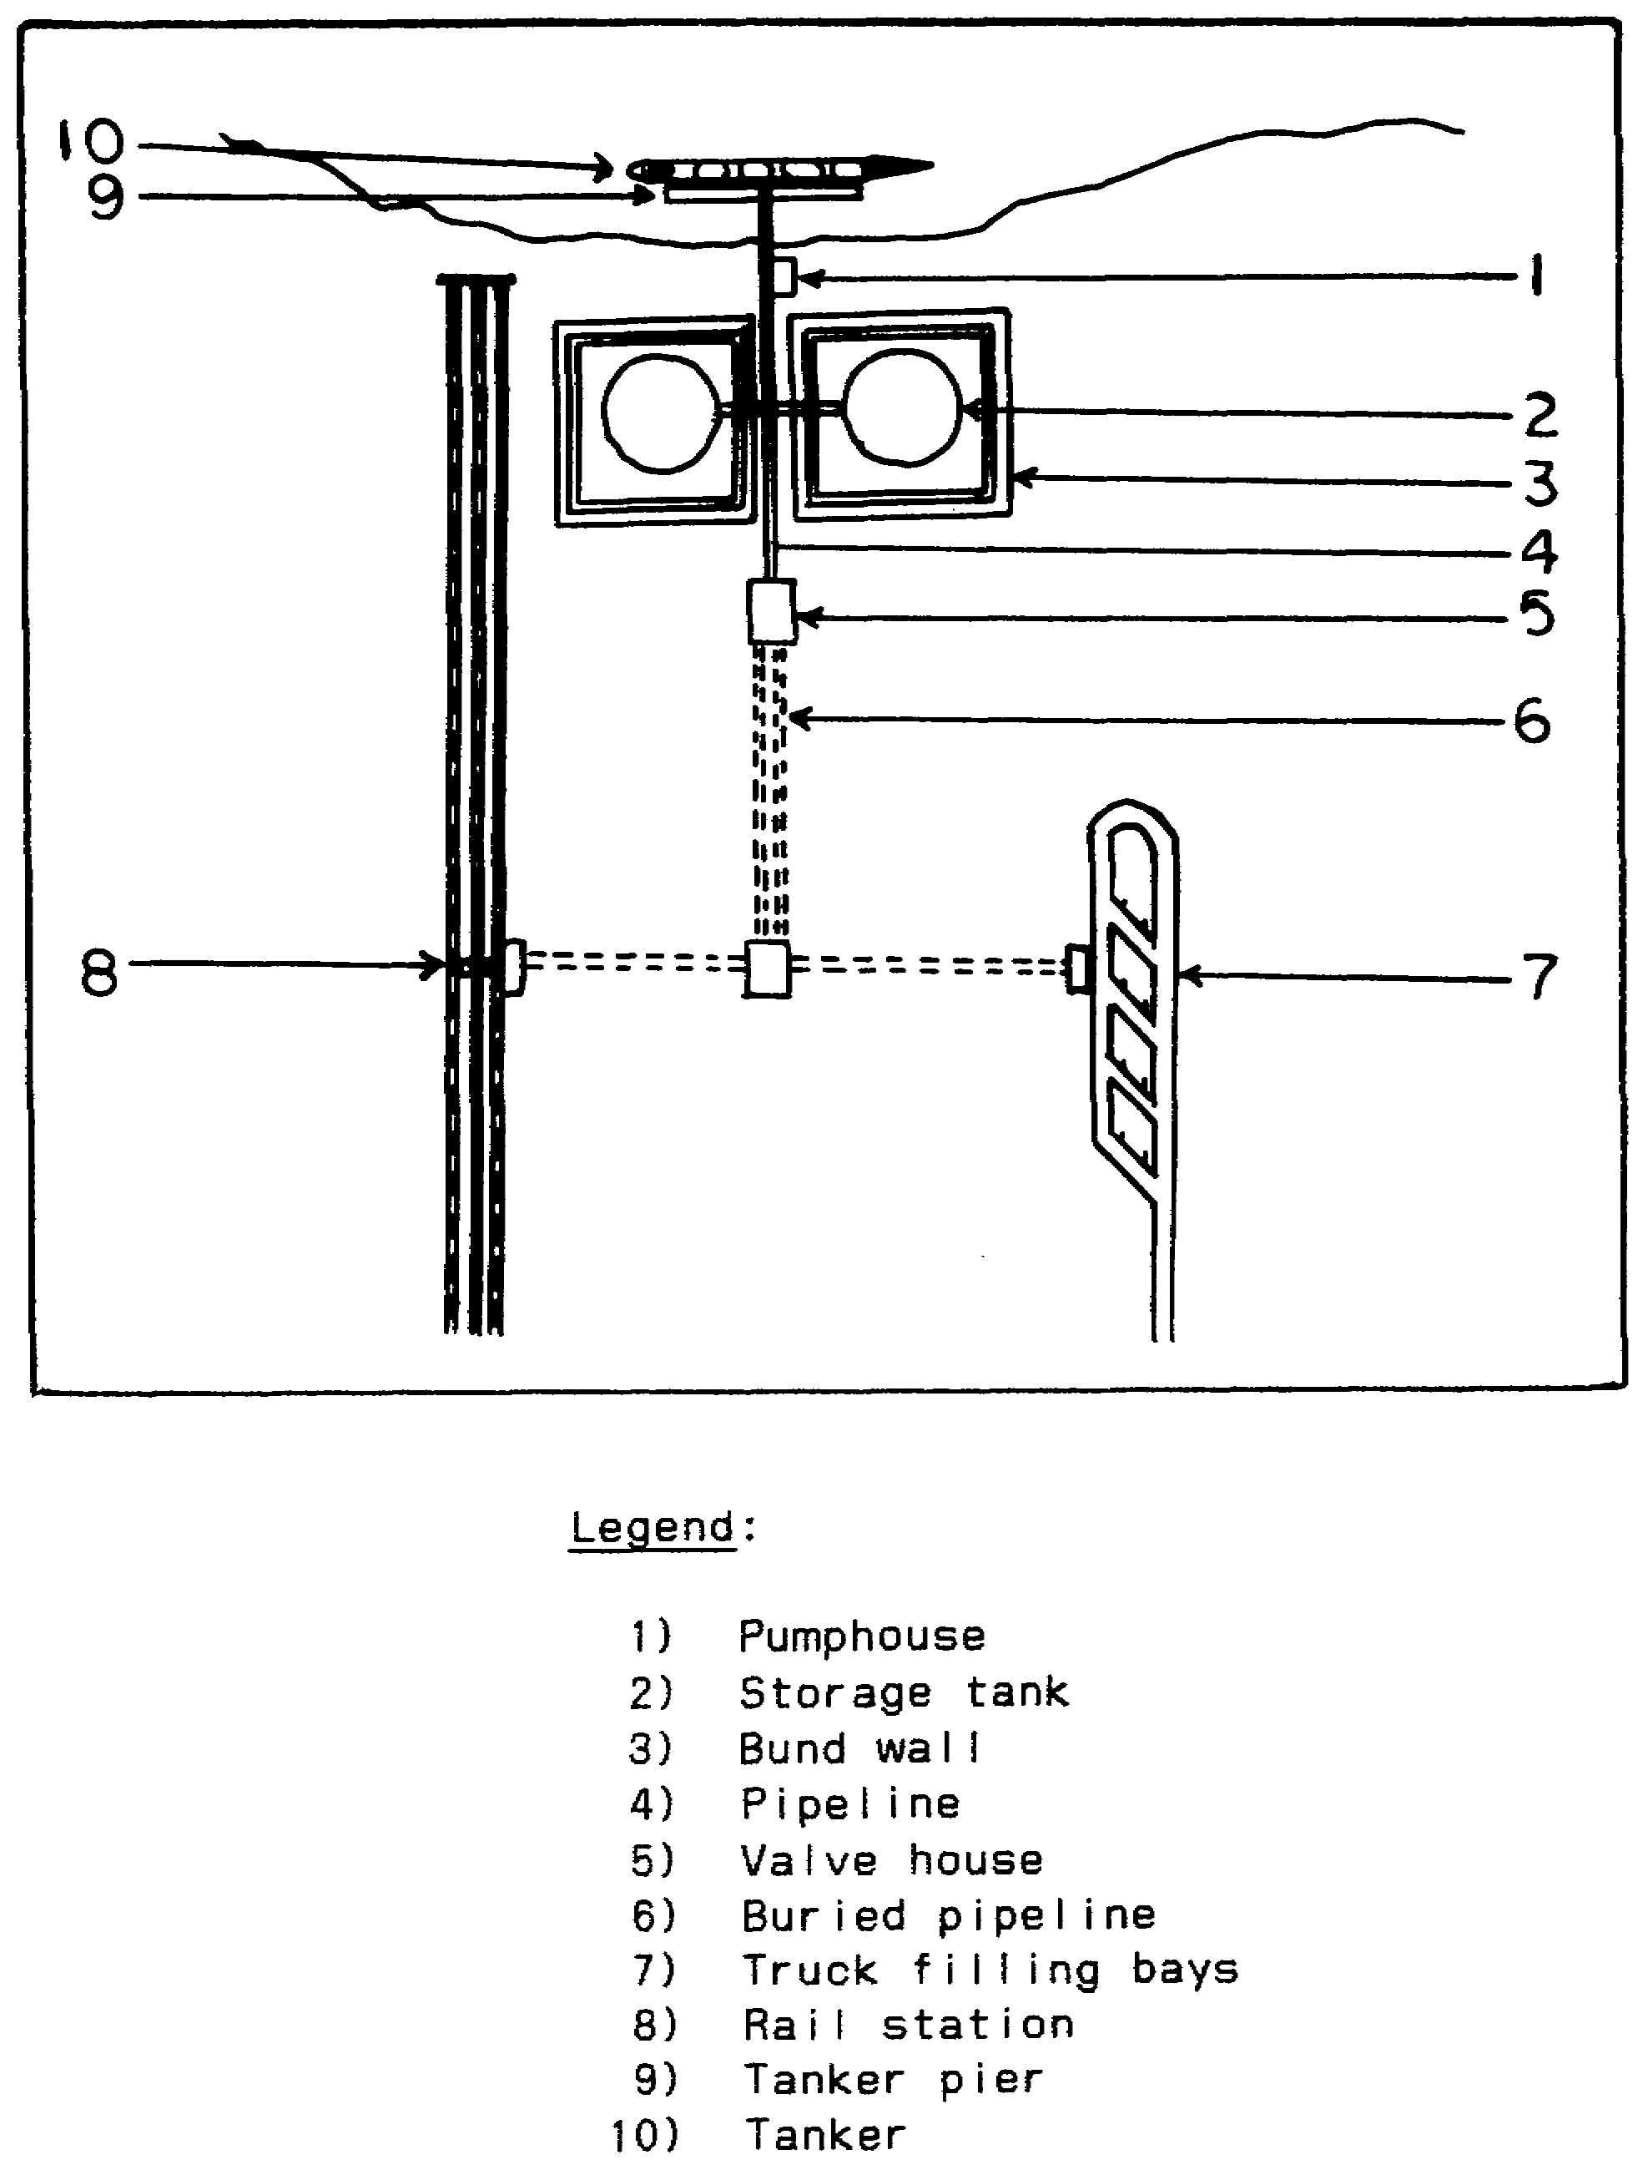

Figure 2-16. Fuel Storage--Water Site.

IT0660 38

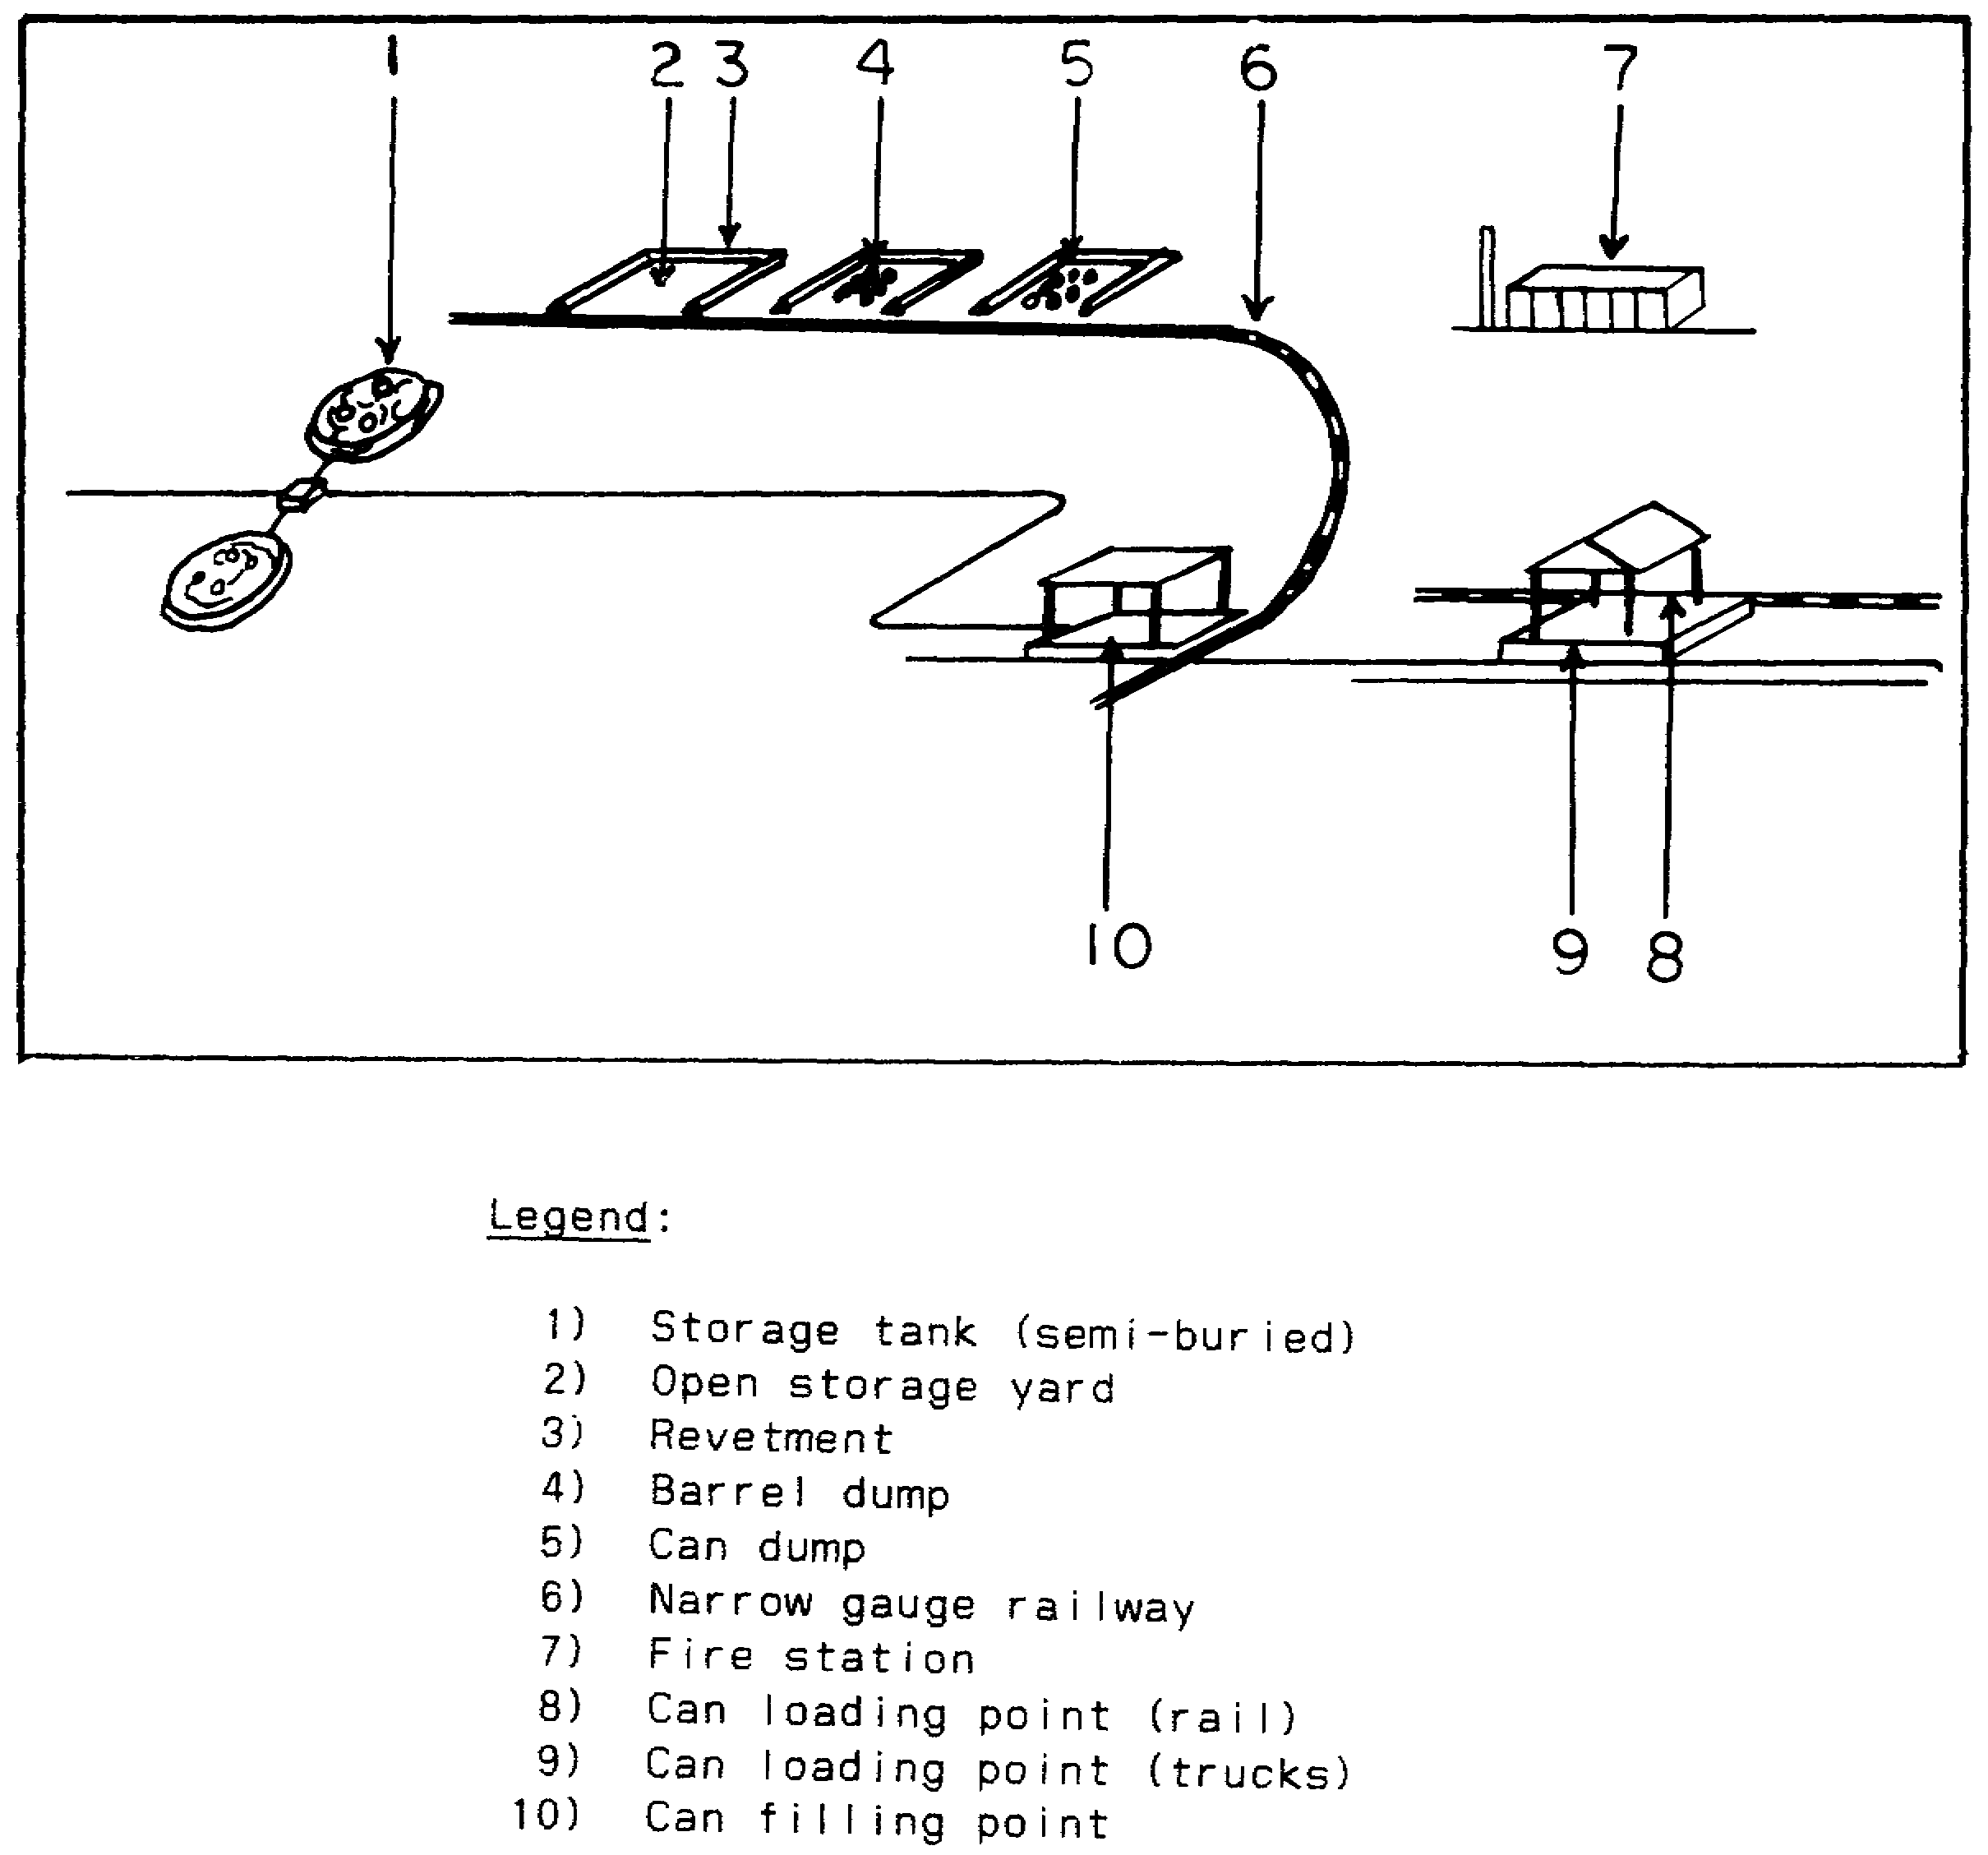

Figure 2-17. Fuel Storage--Rail Site.

39 IT0660

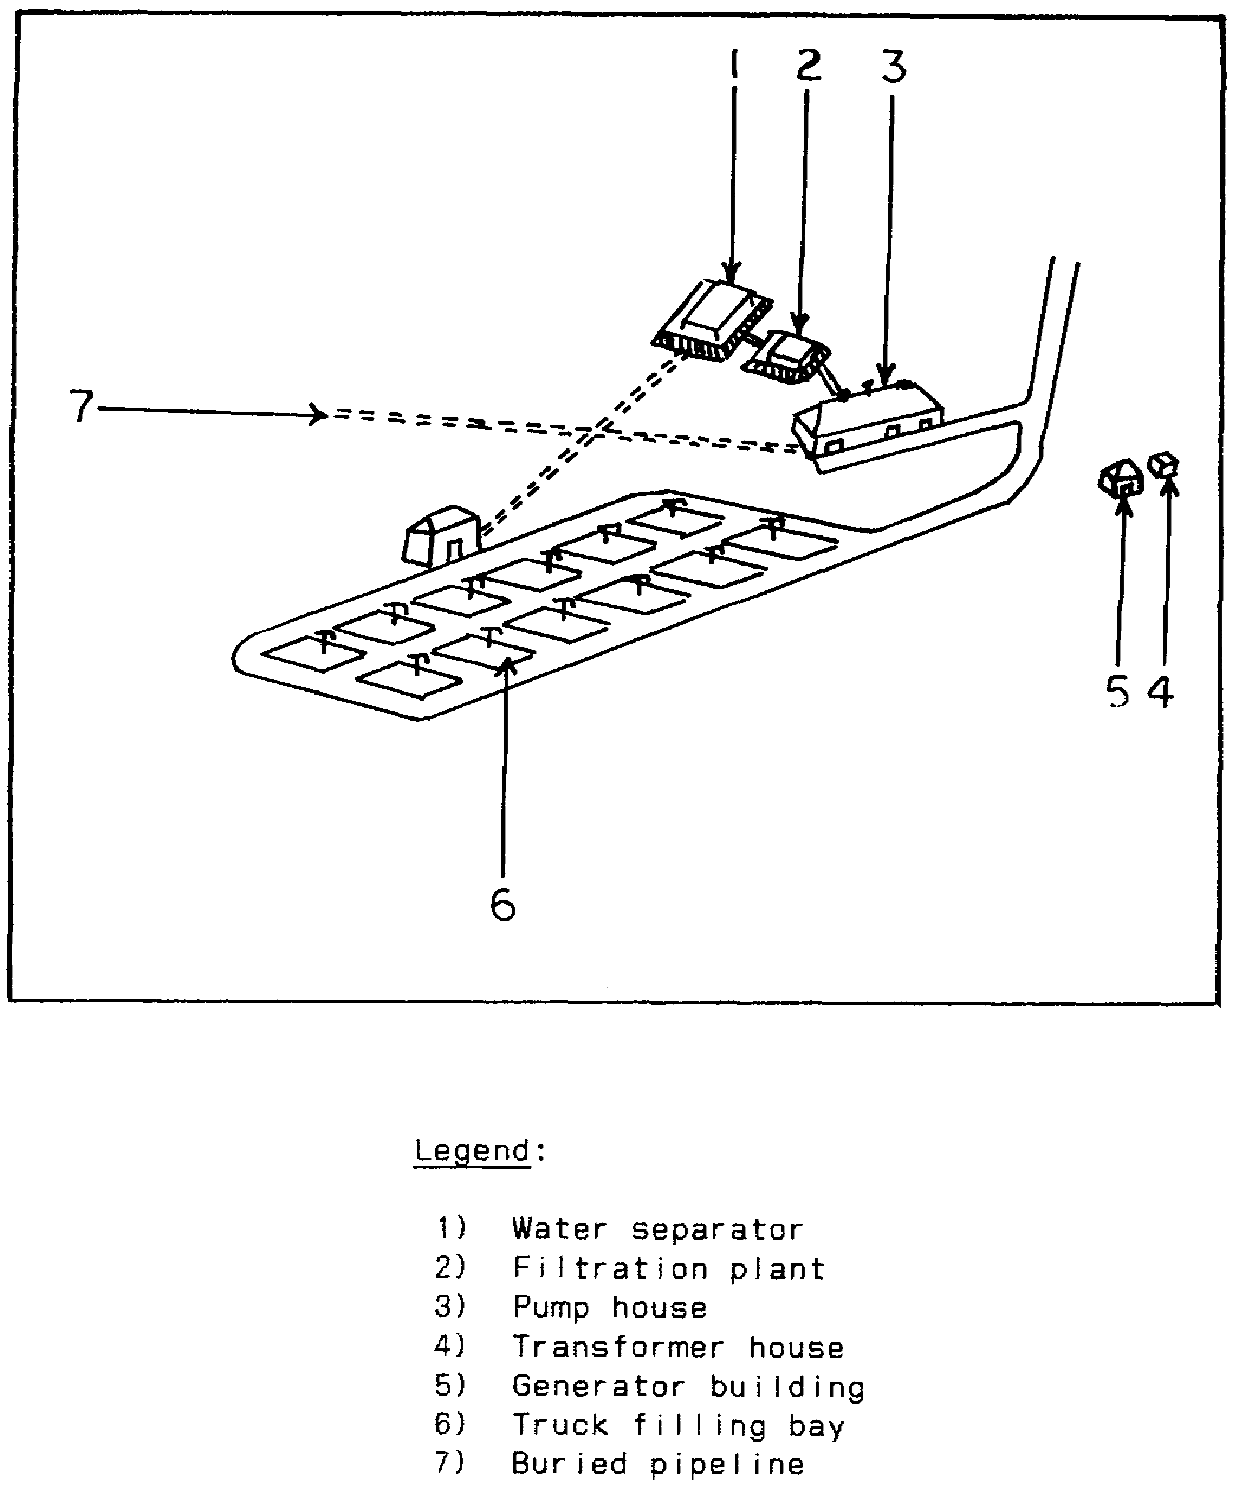

Figure 2-18. Fuel Storage--Motorized Transshipment Site.

IT0660 40

g. General supplies include many items which do not require special handling. Food, clothing, light machinery, spare parts, and many other items are crated or boxed. In very few instances will you find specially formed crates or boxes which allow separate identification of contents. A hypothetical crate measuring 4 feet x 4 feet x 4 feet might contain a generator, cases of dehydrated food, overcoats, or any of several other items. These items can be stored in warehouses or buildings (Figure 2-19) or covered with tarpaulin and placed in bunkers or caves, thereby denying the IA the opportunity to analyze the containers. As a result, the IA locating such an installation reports it as a supply dump, or depot (Figure 2-20) and gives its location and approximate dimensions.

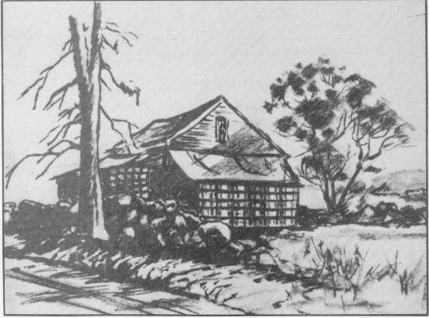

Figure 2-19. General Supply Storage Warehouse.

41 IT0660

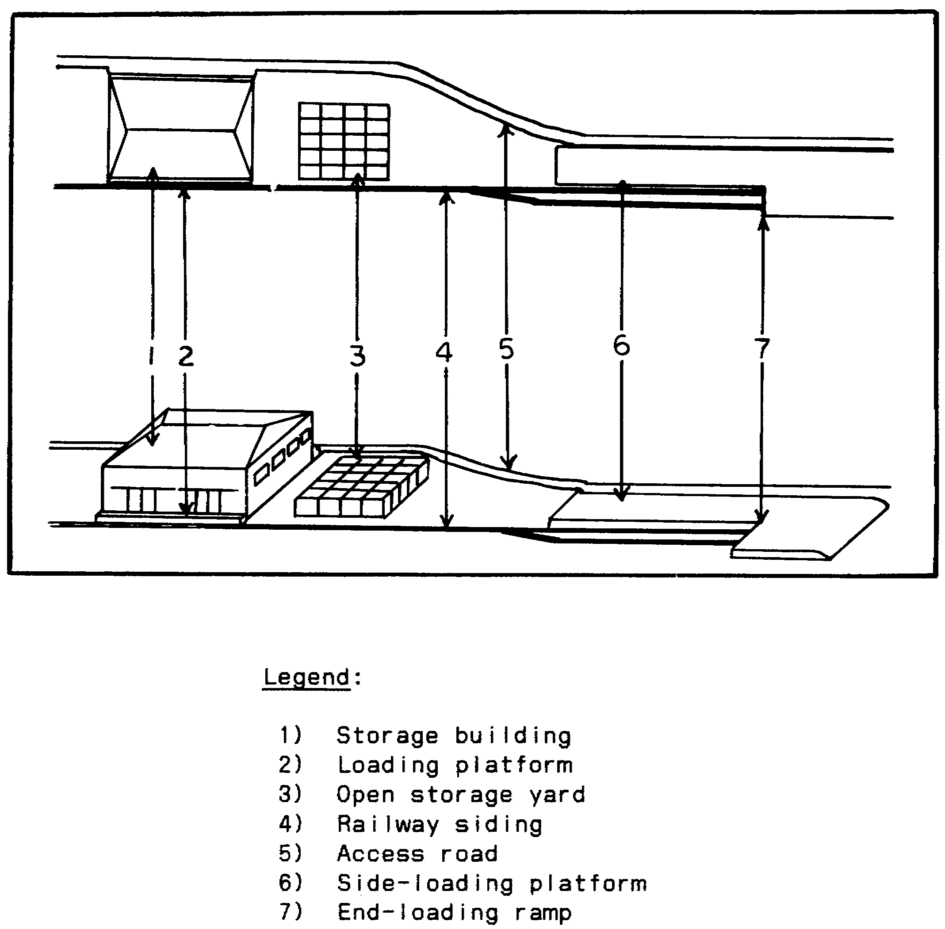

Figure 2-20. Supply Depot.

IT0660 42

4. Firing ranges are found in open terrain and near home stations. Ranges in open terrain usually have the vegetation removed and a clear field of fire; furthermore, there is a control tower. They are easily recognized. On the other hand, ranges near home stations are usually scaled ranges to reduce the rising cost of ammunition, fuel, and spare parts. The following examples are typical ranges.

a. The standard rifle marksmanship field firing range consists of approximately 35 firing lanes, each lane has a fighting position (foxhole), stump, and sandbags. There are three rows or banks of targets, one bank is located at a range of 75 m, the second at 175 m, and the third at 300 m Figure 2-21).

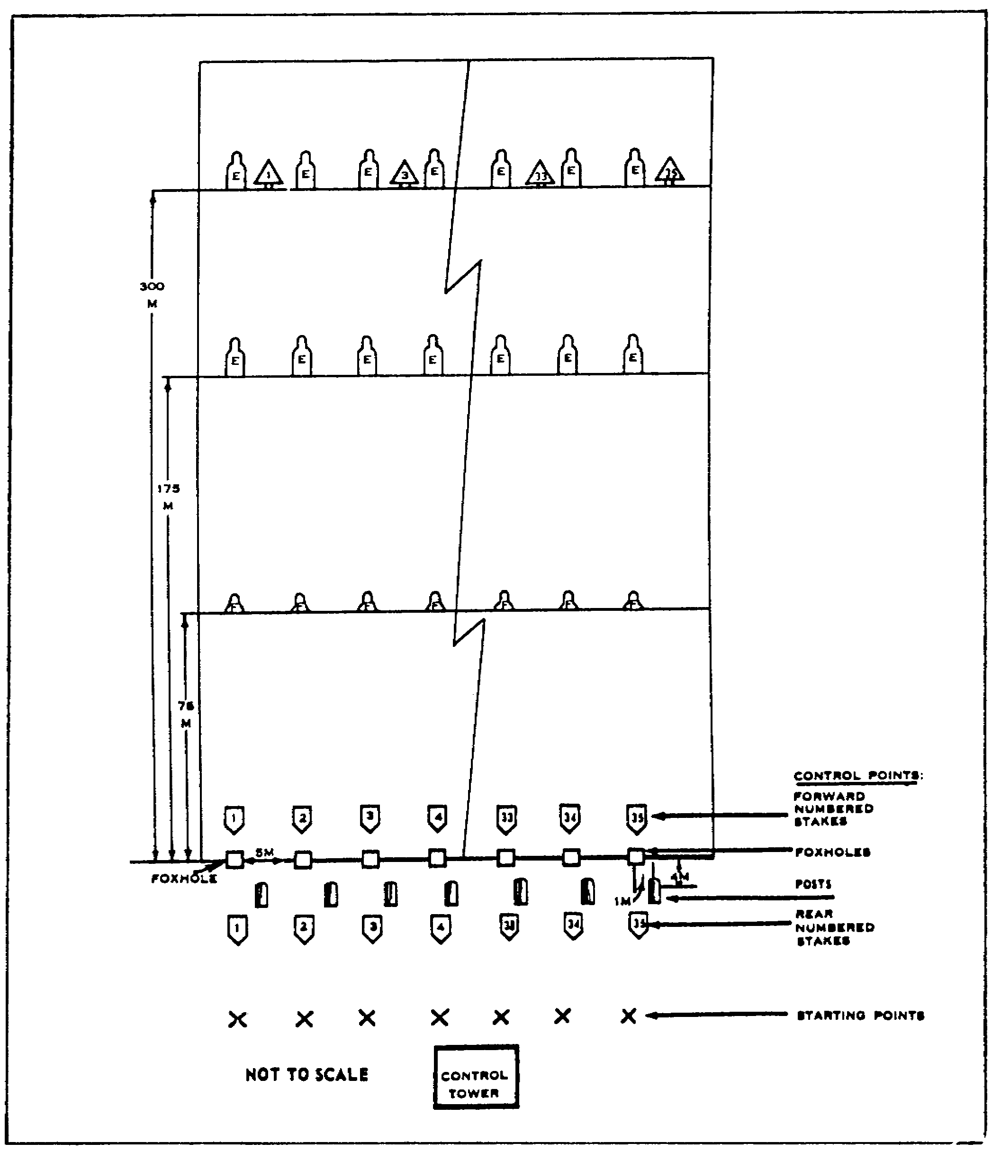

Figure 2-21. Standard Rifle Marksmanship Field Firing Range.

43 IT0660

b. A crack and thump detection range is a live firing range. It is constructed on terrain that slopes downward for 500 m and then upward for 200 m. The term "crack" refers to the sound of a projectile (exceeding the speed of sound) as it passes near the individual. The term "thump" refers to the sound caused by the expanding gases escaping into the atmosphere when a weapon is fired (Figure 2-22).

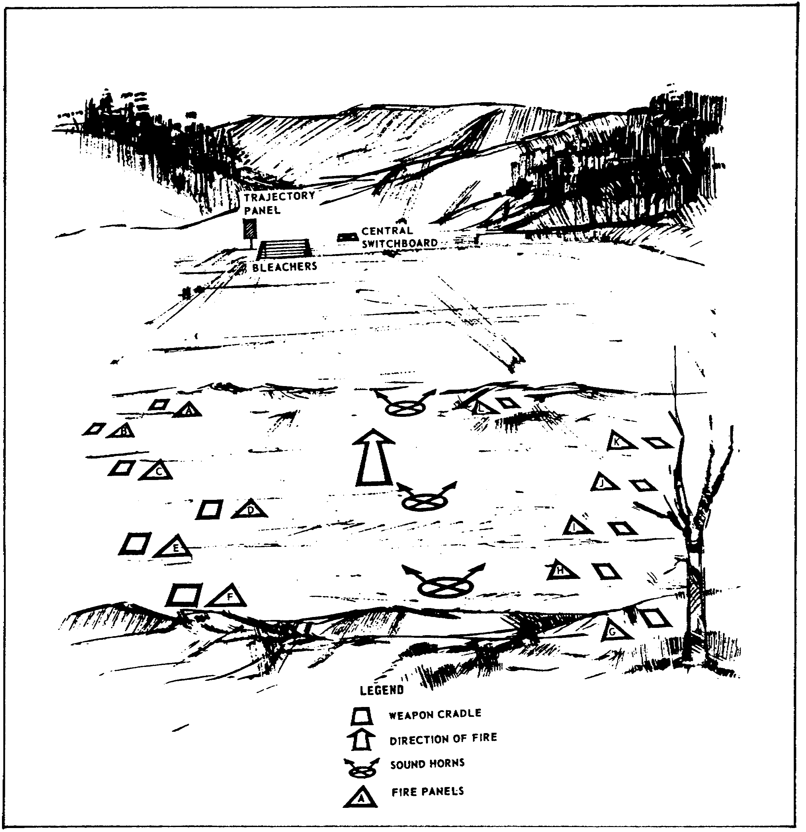

Figure 2-22. Crack and Thump Target Detection Range.

IT0660 44

c. The standard record rifle firing range is usually located on ground with a gradual downward slope for approximately 200 m and then a gradual upward slope for an additional 100 m. The standard record range depth is divided into 16 lanes with one fighting position in each lane (Figure 2-23).

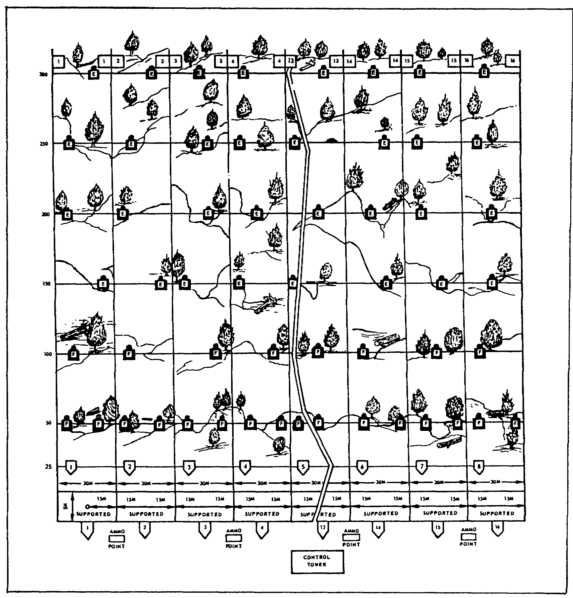

Figure 2-23. Standard Record Rifle Firing Range.

45 IT0660

d. A machine-gun field firing range is set up with lanes 20 m wide at the firing line and 100 to 200 m wide at the end of the lane. The lanes are approximately 1,100 m long. The terrain is usually irregular and there are bleachers behind the firing line (Figure 2-24).

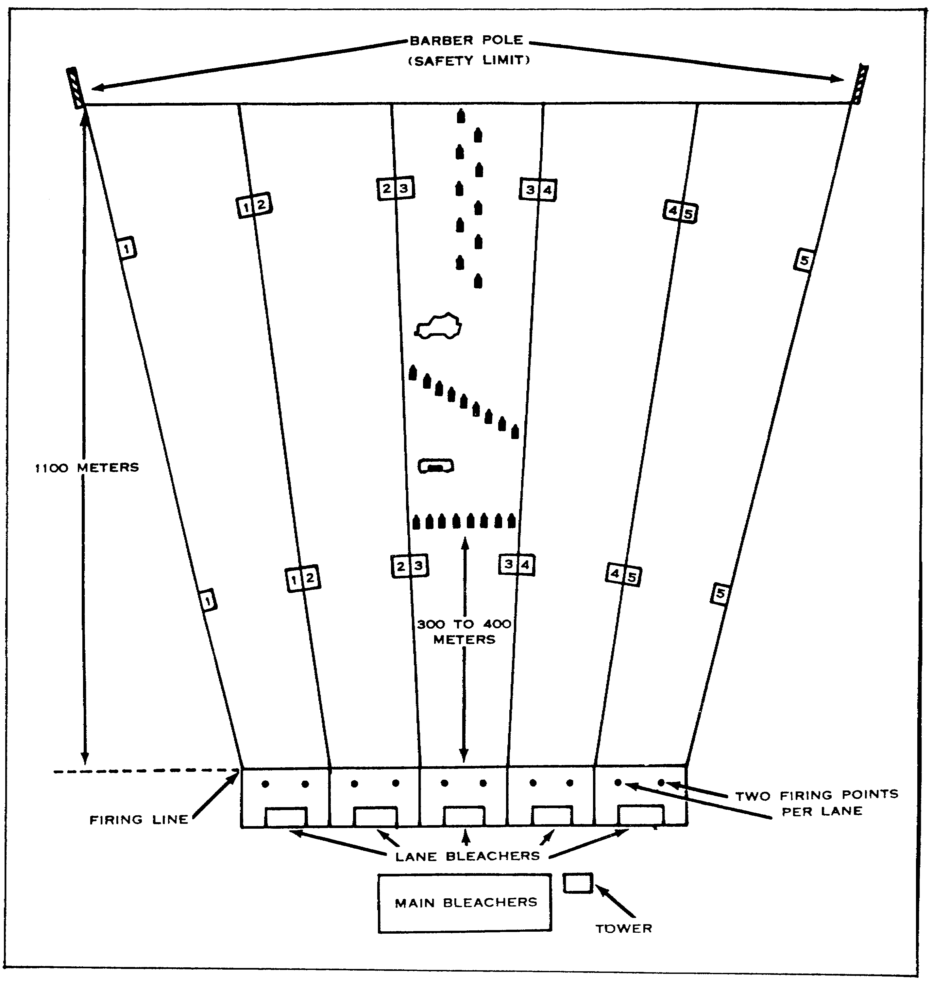

Figure 2-24. Daylight Defensive Field Machine-gun Firing Range.

IT0660 46

e. Scaled ranges are used for tank and fighting vehicle gunnery. The size of the range depends on the area available and the caliber of the device used. The size of the required impact area is reduced by adding berms (Figure 2-25).

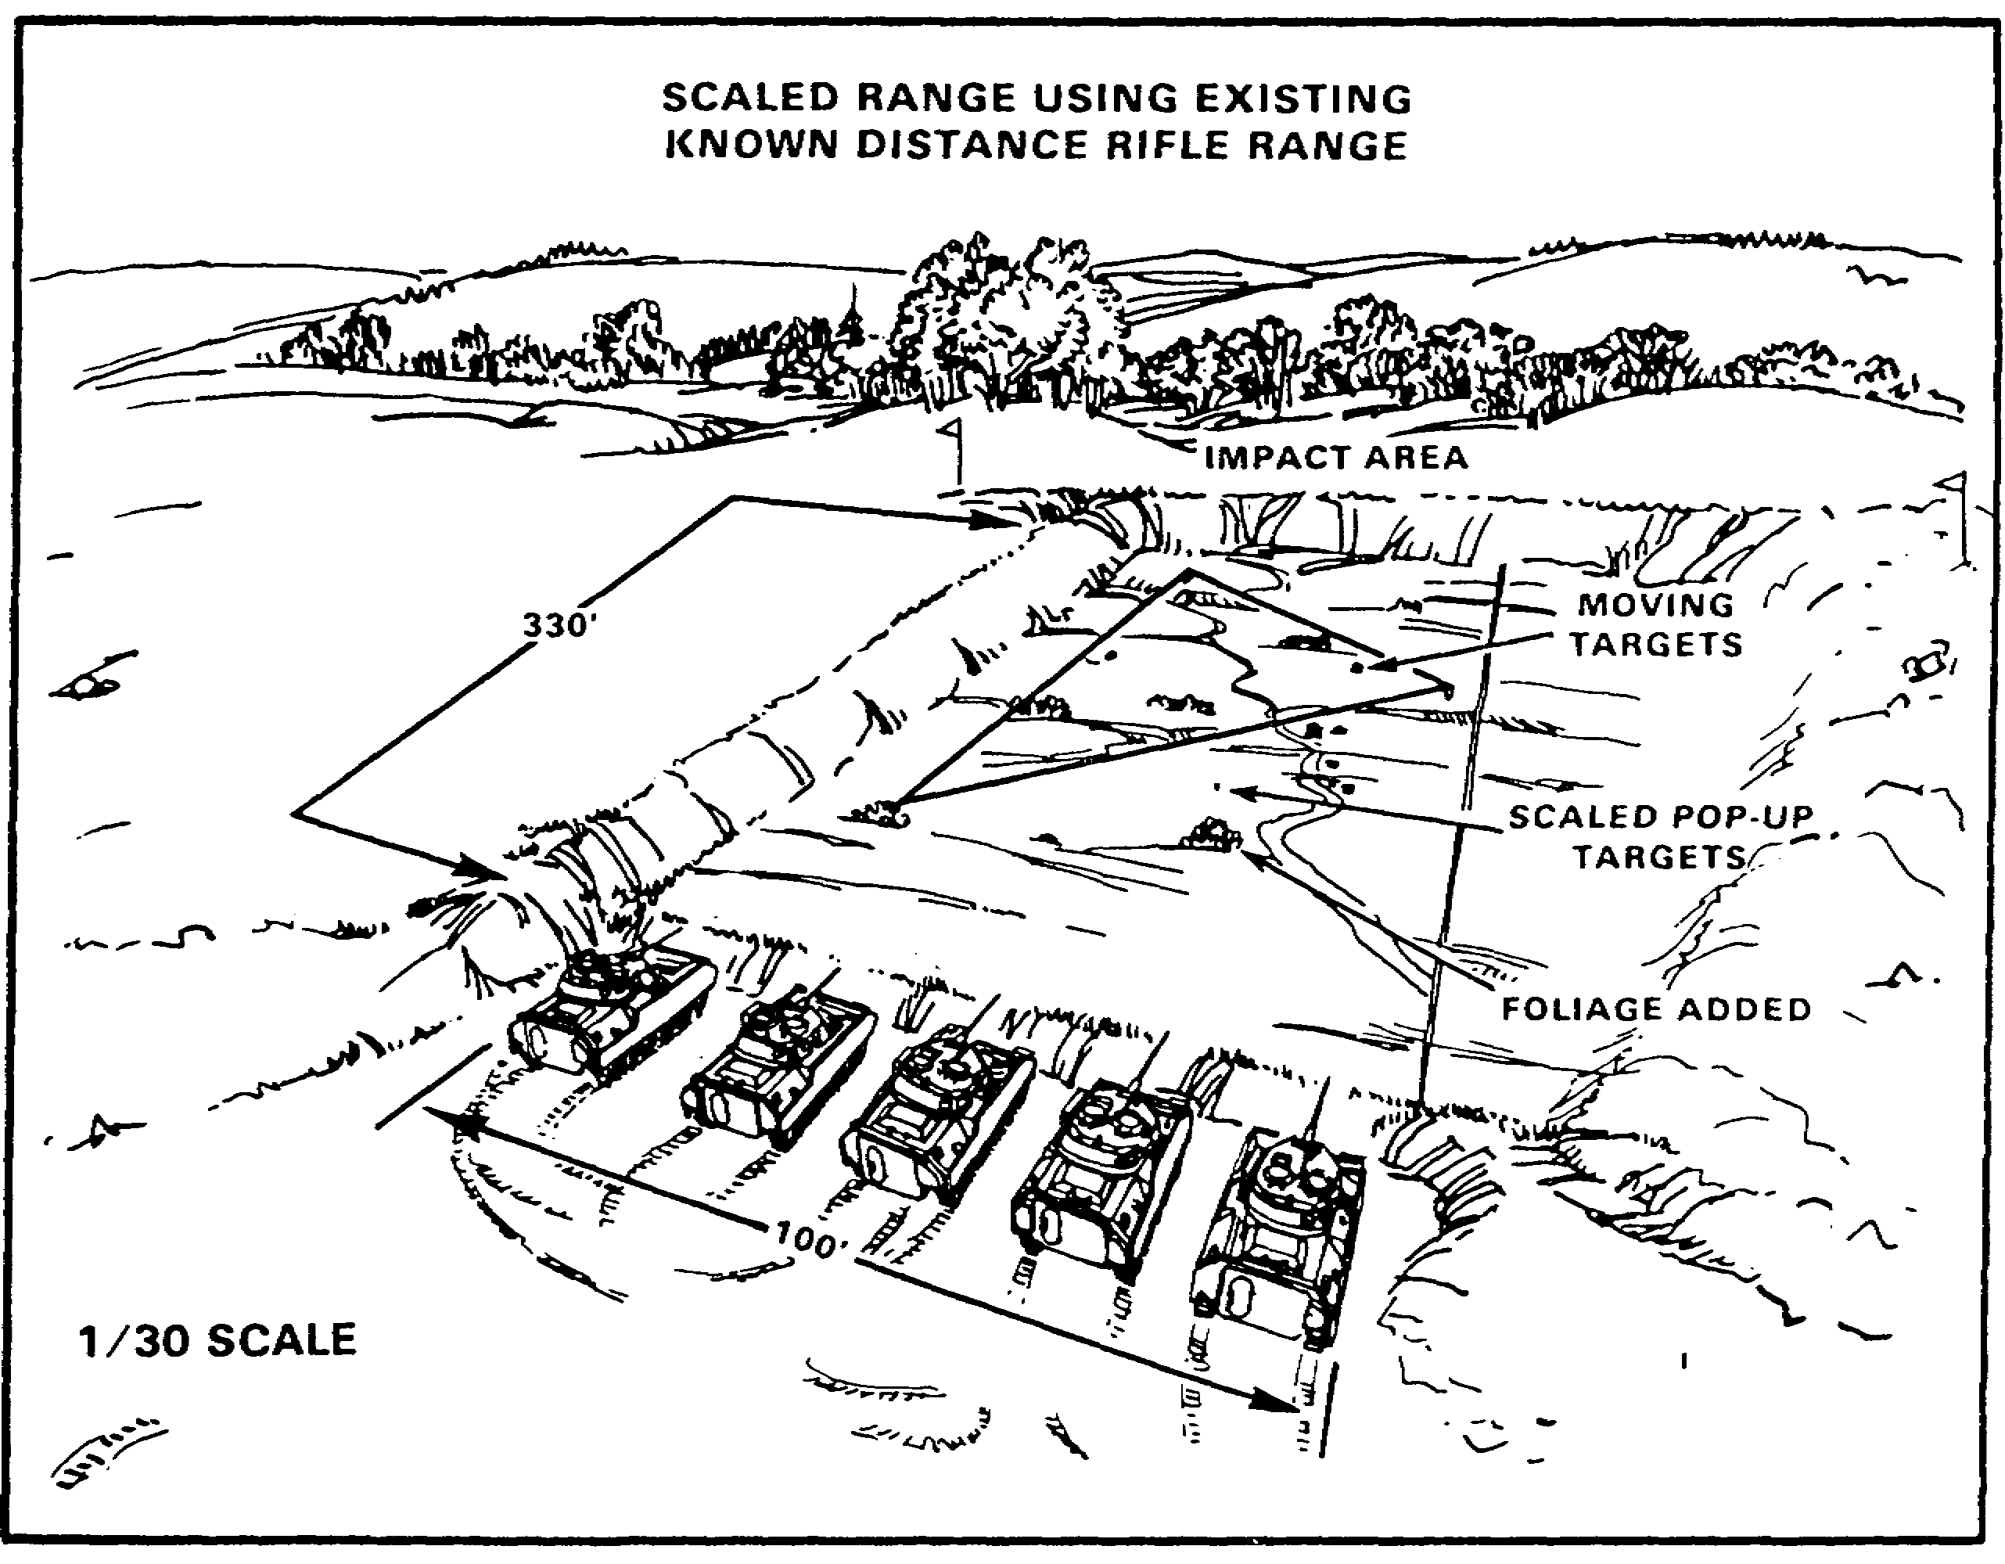

Figure 2-25. Scaled Range.

47 IT0660

LESSON TWO

PRACTICE EXERCISE

The following items will test your grasp of the material covered in this lesson. There is only one correct answer to each item. When you have completed the exercise, check your answers with the answer key that follows. If you answer any item incorrectly, study again that part of the lesson which contains the portion involved.

1. What is a prerequisite to identifying troops on foot?

A. Small scale photography.

B. Large scale photography.

C. Medium scale photography.

D. Casted shadows.

2. Which radar usually indicates the presence of a missile guidance radar?

A. Antenna masts.

B. Bunkered.

C. Domed.

D. Radio transmitter.

3. What type housing facility includes huts, tents, and commandeered housing?

A. Permanent.

B. Temporary.

C. Cantonment.

D. Expedient.

IT0660 48

4. What type of tactical facility is located at Annotation A in Figure 2-26?

A. CP.

B. DTOC.

C. CTOC.

D. Bivouac.

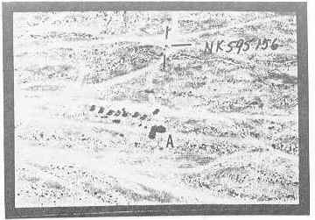

Figure 2-26.

Refer to Figure 2-27 for questions 5 and 6.

5. What type storage is shown in area A?

A. Ammunition.

B. POL.

C. Rations.

D. Open.

6. What type plant is in the immediate area?

A. Oil refinery.

B. Processing.

C. Ordnance.

D. Vehicle manufacturing.

49 IT0660

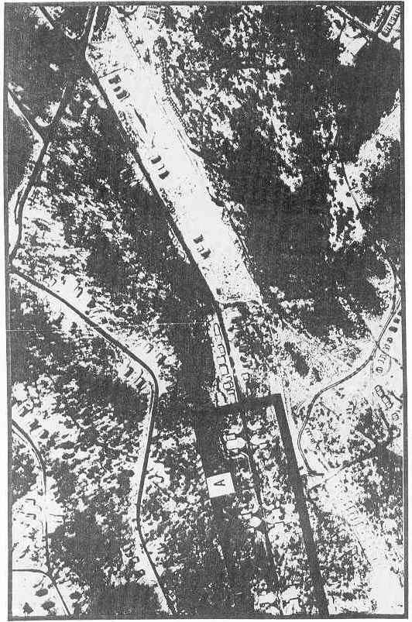

Figure 2-27.

IT0660 50

7. Which type military activity is normally configured in loops and in a wooded area near a major road?

A. Bivouac area.

B. Truck park.

C. Campsite.

D. Motor pool.

8. What is the major difference between a rifle range and a machine-gun range?

A. Rifle range has a control tower.

B. Machine-gun range is longer.

C. Rifle range has a firing line.

D. Machine-gun range is scaled.

51 IT0660

LESSON TWO

PRACTICE EXERCISE

ANSWER KEY AND FEEDBACK

Item Correct Answer and Feedback

1. B. Troops on foot can only be identified on large scale photography
(para 18, para 1).

2. C. A domed radar usually indicates the presence of a missile guidance site (page 20, para 4/fig 2-4).

3. D. Expedient housing includes huts, tents, and commandeered housing (page 23, para 1b(3)).

4. A. A CP is located at Annotation A, Figure 2-21 (pages 24/26, paras 2a/2a(3)).

5. A. Ammunition (or bombs) is stored in area A of Figure 2-22 (pages 34/35, paras 3d/3e, figs 2-13/2-14).

6. C. An ordnance plant is in the immediate area of an ammunition plant (page 35, note).

7. B. You can identify a truck park in a wooded area near a major road (page 18, para 2a).

8. B. The machine-gun range is longer (1,100 m) while a rifle range is only 300 m (pages 43/46, figs 2-21/2-24).

IT0660 52

